Section 9.7: Cylindrical and Spherical Coordinates

Practice HW from Stewart Textbook (not to hand in)
p. 689 # 3-23 odd

Cylindrical Coordinates

In the cylindrical coordinate system, a point P in 3D space is represented by the ordered triple $(r,θ,z)$. Here, r represents the distance from the origin to the projection of the point P onto the x-y plane, $θ$ is the angle in radians from the x axis to the projection of the point on the x-y plane, and z is the distance from the x-y plane to the point P.
z

$$P(r,θ,z)$$

y
r

$$θ$$

█
x

The following equations can be used to convert from rectangular to cylindrical coordinates and vise versa.

Sine and Cosine of Basic Angle Values

$θ$ Degrees | $θ$ Radians | $$\text{cos}θ$$ | $$\text{sin}θ$$
0 | 0
30 | $$\frac{π}{6}$$
45 | $$\frac{π}{4}$$
60 | $$\frac{π}{3}$$
90 | $$\frac{π}{2}$$
180 | $π$
270 | $$\frac{3π}{2}$$
360 | $$2π$$

Example 2: Make a rough sketch of the equation $f(x,y)=\text{cos}y$.

Solution:

z

y

x

█

Graphing Planes

Recall that the equation of a plane is given by $\text{ax}+\text{by}+\text{cz}=d$ (note that the variables x, y, To make a rough sketch of a plane in 3D space, it is easiest to find the points of intersection with the coordinate axes.
Example 3: Make a rough sketch of the equation $f(x,y)=4$.

Solution:

z

y

x

█

Example 4: Make a rough sketch of the equation $x+2y=4$.

Solution:

x
y
z

█

Example 5: Make a rough sketch of the equation $z=f(x,y)=−3x−6y+6$.

Solution:

z

y

x

█

Quadric Surfaces

Quadric surfaces are the 3D analog of the conic sections in 2D.

Conic Sections is 2D

Parabolas

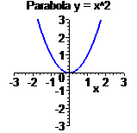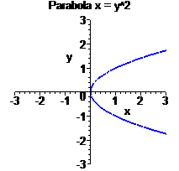

Ellispe

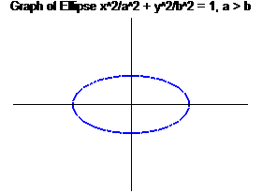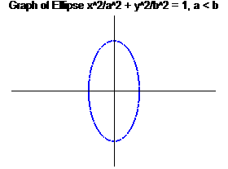

Hyperbola

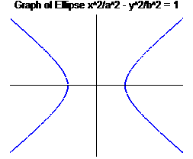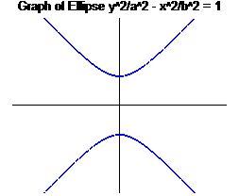

Types of Quadric Surfaces (summary on p.682 text)

Ellispsoid

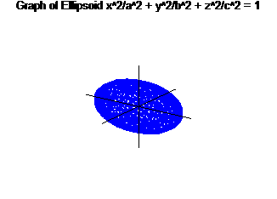
Hyperboloid (One Sheet)

Note: The axis the graph is projected along is the variable with the negative coefficient.

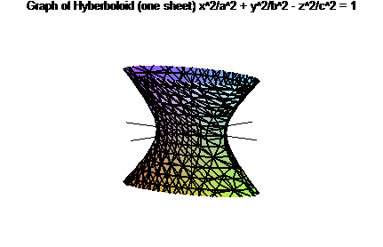
Hyperboloid (Two Sheets)

Note: The axis the graph is projected along is the variable with the positive coefficient.

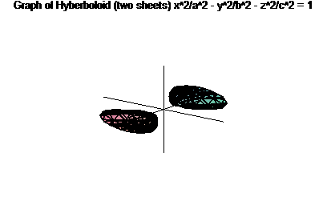

Elliptic Cone

Axis of projection is the variable with the negative coefficient

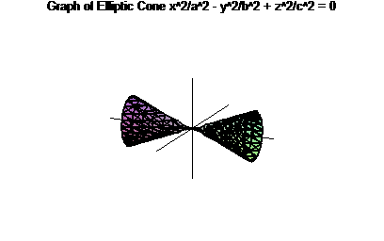

Elliptic Paraboloid

Axis of projection is the variable term raised to the 1st power.

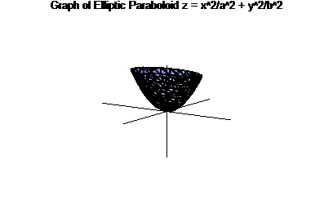

Hyperbolic Paraboloid

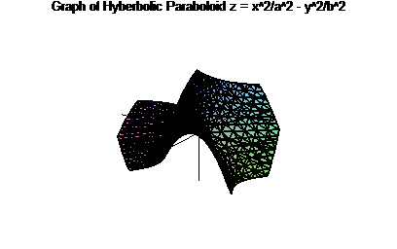

Note: To sketch a 3D quadric surface, sometimes it can be useful to set each variable equal to 0 and sketch the corresponding 2D curve. This is known as a trace.
Example 6: Identify and make a rough sketch of the quadric surface $x^{2}−\frac{y^{2}}{4}−z^{2}=1$.

Solution:

z

y

x

█

Example 6: Identify and make a rough sketch of the quadric surface $\text{16}x^{2}+9y^{2}+9z^{2}=\text{144}$.

Solution:

z

y

x

█

Example 6: Identify and make a rough sketch of the quadric surface $y=4x^{2}+z^{2}$.

Solution:

z

y

x

█

