Section 12.4: Double Integrals in Polar Coordinates

Practice HW from Stewart Textbook (not to hand in)
p. A66 Appendix H: # 1-6
p. 856 Section 12.4: # 1-21 odd, 25, 27 odd

Polar Coordinates

Up to now , we have represented graphs as a collection of points (x, y) in the rectangular coordinate. For example, the following represents the graph of the circle $x^{2}+y^{2}=4$ in rectangular coordinates.

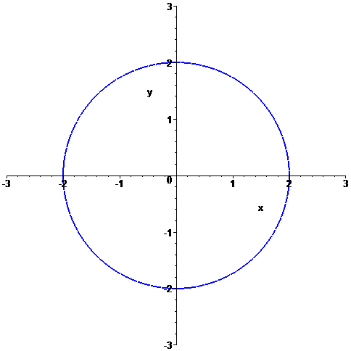

Equations like this can be expressed in polar coordinates.

In polar coordinates, each coordinate is of the form $(r,θ)$

$$(r,θ)$$

r

$θ$ = angle of rotation

Polar Axis (usually x-axis)
Pole (usually origin)

In polar coordinates, for the circle $x^{2}+y^{2}=4$, the points on the circle have a different representation.

Note: Polar Coordinates are not unique – there may be more than one way to represent the same point.

In general, $(r,θ)$ and $(r,θ+2nπ)$, where n is an integer, give the same point.

For example, $(2,\frac{π}{2})$ and $(2,\frac{π}{2}+2π)=(2,\frac{5π}{2})$ represent the same point. Also, $(2,π)$
and $(2,3π)$ represent the same point.

y

x

Note: r can also be negative. The points $(r,θ)$ and $(−r,θ)$ lie on the line same line through the pole O and the same distance | r | from O, but on opposites sides of O. The points $(r,θ+π)$ and $(−r,θ)$ represent the same point.

x
y

O

Example 1: Plot the points with polar coordinates $(2,\frac{π}{3})$, $(−2,\frac{π}{3})$, $(1,\frac{5π}{4})$, and $(−3,\frac{\text{11}π}{6})$.

Solution:

█
Example 2: Plot the point with polar coordinates $(4,π)$. Then find two other pairs of polar coordinates of this point, one with r > 0 and the other r < 0.

Solution:

█

Conversion of Rectangular and Polar Coordinates

Consider the following diagram:

y

$$(x,y)=(r,θ)$$

x

We say $\text{cos}θ=\frac{\text{adjacent}}{\text{hypotenuse}}=\frac{x}{r}$, $\text{sin}θ=\frac{\text{opposite}}{\text{hypotenuse}}=\frac{y}{r}$, and $\text{sin}θ=\frac{\text{opposite}}{\text{adjacent}}=\frac{y}{x}$.

Using these equations and the Pythagorean Theorem, we have the following conversion equations.

Conversion Formulas

To convert from polar form $(r,θ)$ to rectangular form (x, y) and vise versa, we use the following conversion equations.

From polar to rectangular form: $x=r\text{cos}θ$ and $y=r\text{sin}θ$.

From rectangular to polar form: $r^{2}=x^{2}+y^{2}$ and $\text{tan}θ=\frac{y}{x}$.

Example 3: Find the corresponding rectangular coordinates for the point $(1,\frac{5π}{4})$.

Solution:

█
Example 4: Find the polar coordinates for the point (0, -5).

Solution:

█

Converting Equations

Example 5: Convert the equation $x=\text{10}$ to polar form.

█
Example 5: Convert the equation $x^{2}+y^{2}−2x=0$ to polar form.

█

Graphing Polar Equations

One way to graph polar equations is to convert it to rectangular form and sketch the rectangular equation.

Example 6: Convert r = 3 to rectangular form and sketch the graph.

Solution:

█
Example 7: Convert $r=2\text{sec}θ$ to rectangular form and sketch the graph.

Solution:

█

Note: In general, sketching graphs is polar form is not an easy task. Maple can be a useful tool in graphing. The following shows the Maple commands necessary to graph the polar graphs $r=5−4\text{sin}θ$ and $r=2\text{cos}(3θ)$ (next page)

> with(plots):
> r := 5 - 4*sin(theta);
> polarplot(r, theta = 0..2*Pi, thickness = 2, title = "Graph of r = 5 - sin(theta)");

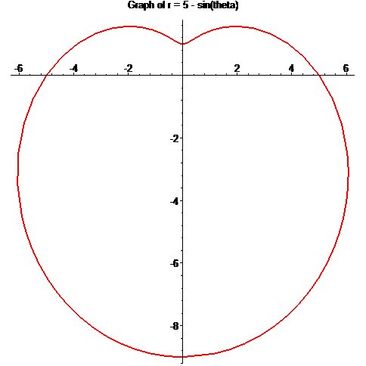

> r := 2*cos(3*theta);
> polarplot(r, theta = 0..2*Pi, thickness = 2, title = "Graph of r = 2cos(3*theta)");
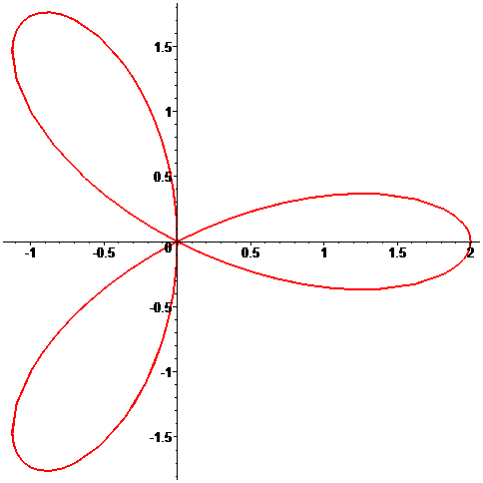

Evaluating Double Integrals Using Polar Coordinates

Changing a double integral from rectangular to polar coordinates can sometimes result in an integral that is easier to evaluate.

Suppose we have a region R on the x-y plane satisfying the polar conditions

$0≤g_{1}(θ)≤r≤g_{2}(θ)$ and $θ_{1}≤θ≤θ_{2}$.

x
y
$$g_{2}(θ)$$

$$g_{1}(θ)$$

$$θ_{1}$$
$$θ_{2}$$

Then if the function of two variables z = f (x, y) is defined over R, we say that

$$\begin{matrix}\text{Volume under} \\ z=f(x,y)≥0\text{ over R}\end{matrix}=\iint_{R}{f(x,y)\text{dA}=\int{\int{f(r\text{cos}θ,r\text{sin}θ)r\text{dr}dθ}}}$$

Example 8: Use polar coordinates to evaluate $\iint_{R}{(x+y)\text{dA}}$ where R is the region that lies I in the first quadrant between the circles $x^{2}+y^{2}=1$ and $x^{2}+y^{2}=4$.

Solution:

█
Example 9: Find the volume under the surface $z=e^{−x^{2}−y^{2}}$ and above the disk $x^{2}+y^{2}≤4$.

Solution:

█
Example 10: Evaluate the iterated integral $\int_{0}^{2}{\int_{y}^{\sqrt{8−y^{2}}}{\sqrt{x^{2}+y^{2}}}\text{dx}\text{dy}}$

Solution:

█

