Section 12.7: Triple Integrals

Practice HW from Stewart Textbook (not to hand in)
p. 879 # 1-19 odd

Consider a continuous function of 3 variables f (x, y, z) on the solid bounded region E on the 3D plane.
x
y
z

$$←z=g_{2}(x,y)$$

E
$$←z=g_{1}(x,y)$$

D

Then
$$\begin{matrix}\text{The Triple Integral} \\ \text{of }f\end{matrix}=\iiint_{E}{f(x,y,z)\text{dV}}$$

$$\begin{matrix}\text{Volume of the} \\ \text{Region Q}\end{matrix}=\iiint_{E}{\text{dV}}$$

We evaluate a triple integral by writing it as an integrated integral.

$$\iiint_{E}{f(x,y,z)\text{dV}}=\int_{x=a}^{x=b}{\int_{y=h_{1}(x)}^{y=h_{2}(x)}{\int_{z=g_{1}(x,y)}^{z=g_{2}(x,y)}{ f(x,y,z)\text{dz}\text{dy}\text{dx}}}}$$

where the limits of integration are defined on the boundaries of E.
Example 1: Evaluate the iterated integral $\int_{1}^{4}{\int_{1}^{e^{2}}{\int_{0}^{\frac{1}{\text{xz}}}{\text{ln}\text{z }\text{dy}\text{dz}\text{dx}}}}$

Solution:

█

Example 2: Evaluate $\iiint_{E}{2\text{xy}}$ where E lies under the plane $x+y+z=\text{10}$ and above the region in the x-y plane bounded by the curves in the first octant y = 0 and y = $\sqrt{\text{16}−x^{2}}$.

Solution:

█
Example 3: Use a triple integral to find the volume of the solid bounded by the graphs of $z=x^{2}+y^{2}$ and the plane $z=4$.

Solution: The following graph shows a plot of the paraboloid $z=x^{2}+y^{2}$ (in blue), the plane $z=4$ (in red), and its projection onto the x-y plane (in green).

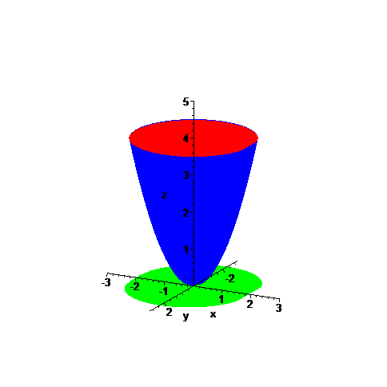
E
D
The triple integral $\iiint_{E}{\text{dV}}$ will evaluate the volume of this surface. In the z direction, the surface E is bounded between the graphs of the paraboloid $z=x^{2}+y^{2}$ and the plane $z=4$. This will make up the limits of integration in terms of z. The limits for y and x are determined by looking at the projection D given on the x-y plane, which is the graph of the circle $x^{2}+y^{2}=4$ given as follows:

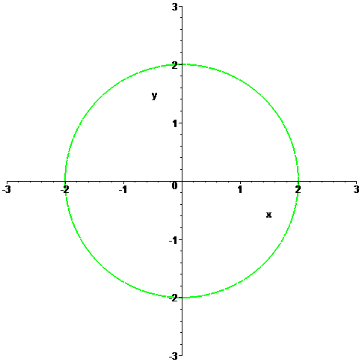
D
(continued on next page)
Taking the equation $x^{2}+y^{2}=4$ and solving for y gives $y=±\sqrt{4−x^{2}}$. Thus the limits of integration of y will range from $y=−\sqrt{4−x^{2}}$ to $y=\sqrt{4−x^{2}}$. The integration limits in terms of x hence range from x = -2 to x = 2. Thus the volume of the region E can be found by evaluating the following triple integral:

$\text{Volume of }E=\iiint_{E}{\text{dV}}= \int_{−2}^{2}{\int_{−\sqrt{4−x^{2}}}^{\sqrt{4−x^{2}}}{\int_{x^{2}+y^{2}}^{4}{\text{dz}\text{dy}\text{dx}}}}$ . If we evaluate the intermost integral we get the following:

$$\begin{aligned}\int_{−2}^{2}{\int_{−\sqrt{4−x^{2}}}^{\sqrt{4−x^{2}}}{\int_{x^{2}+y^{2}}^{4}{\text{dz}\text{dy}\text{dx}}}}=\int_{−2}^{2}{\int_{−\sqrt{4−x^{2}}}^{\sqrt{4−x^{2}}}{ [z]|_{z=x^{2}+y^{2}}^{z=4} }}\text{dy}\text{dx} \\ =\int_{−2}^{2}{\int_{−\sqrt{4−x^{2}}}^{\sqrt{4−x^{2}}}{ \left[4−(x^{2}+y^{2})\right]}}\text{dy}\text{dx}\end{aligned}$$

Since the limits involving y involve two radicals, integrating the rest of this result in rectangular coordinates is a tedious task. However, since the region D on the x-y plane given by $x^{2}+y^{2}=4$ is circular, it is natural to represent this region in polar coordinates.
Using the fact that the radius r ranges from $r=0$ to $r=2$ and that $θ$ ranges from $θ=0$ to $θ=2π$ and also that in polar coordinates, the conversion equation is $r^{2}=x^{2}+y^{2}$, the iterated integral becomes

$$\int_{−2}^{2}{\int_{−\sqrt{4−x^{2}}}^{\sqrt{4−x^{2}}}{ \left[4−(x^{2}+y^{2})\right]}}\text{dy}\text{dx}=\int_{0}^{2π}{\int_{0}^{2}{ (4−r^{2})r}}\text{dr}dθ$$

Evaluating this integral in polar coordinates, we obtain

(continued on next page)

$$\begin{aligned}\int_{0}^{2π}{\int_{0}^{2}{ (4−r^{2})r}}\text{dr}dθ=\int_{0}^{2π}{\int_{0}^{2}{ (4r−r^{3})}}\text{dr}dθ (\text{Distribute }r) \\ \\ =\int_{θ=0}^{θ=2π}{{ (2r^{2}−\frac{1}{4}r^{4})|}_{r=0}^{r=2}}dθ (\text{Integrate}) \\ \\ =\int_{θ=0}^{θ=2π}{[(2(2)^{2}\text{- }\frac{1}{4}(2)^{4})\text{-0}]}dθ (\text{Sub in limits of integration}) \\ \\ =\int_{θ=0}^{θ=2π}{ 4dθ} (\text{Simplify}) \\ \\ =4θ|_{θ=0}^{θ=2π} (\text{Integrate}) \\ \\ =4(2π)−4(0) (\text{Sub in limits of integration}) \\ \\ =8π\end{aligned}$$

Thus, the volume of E is $8π$.

█

