Section 13.1: Vector Fields

Practice HW from Stewart Textbook (not to hand in)
p. 910 # 1-15 odd

Vector fields are functions that assign vectors to a specified point. We can define a vector field as a function of two or three variables as follows.

Definition: Given functions P = P(x, y) and Q = Q(x, y) of two variables. A vector field in 2D space assigns an order pair (x, y) a two dimensional vector F given by

$$F(x,y)=P(x,y)i+Q(x,y)j$$

Given functions P = P(x, y, z), Q = Q(x, y, z), R = R(x, y, z) of three variables. A vector field in 3D space assigns an order pair (x, y, z) a three dimensional vector F given by

$$F(x,y,z)=P(x,y,z)i+Q(x,y,z)\text{j }+R(x,y,z)k$$

Example 1: Sketch several representative vectors in the vector field $F(x,y)=i−j$.

Solution:

█

Example 2: Sketch several representative vectors in the vector field $F(x,y)=yi+j$.

Solution:

█
Example 3: Sketch several representative vectors in the vector field $F(x,y)=\frac{x}{2}i+yj$.

Solution:

█
Example 4: Use Maple to plot the vector field $F(x,y)=\text{cos}x\text{ i}+\text{sin}y\text{ j}$.

Solution: To plot this vector field, we can use the fieldplot command, which is part of the plots package. The following commands give a plot of this vector field.

> with(plots):
> fieldplot([cos(x), sin(y)], x = -3..3, y = -3..3, thickness = 2, color = blue, arrows = SLIM);

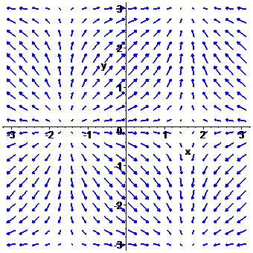

In the previous command, the components of the vector field are placed in brackets, the next two parameters specify the x and y axis ranges (-3..3) of where the vectors will be plotted, thickness = 2 specifies the how thick the arrows are (can be either 1, 2, 3), color specifies the color of the arrows (blue in this case), and arrows specifies how the arrow style (can be LINE, THIN, SLIM and THICK with THIN being the default).

Example 4: Use Maple to plot the vector field $F(x,y)=x\text{ i}+y\text{ j}+z\text{ k}$.

Solution: To plot this vector field, we can use the fieldplot3d command, which is part of the plots package. The following commands give a plot of this vector field.

> with(plots):
> fieldplot3d([x, y, z], x = -3..3, y = -3..3, z = -3..3, thickness = 2, arrows = SLIM, axes = FRAMED);

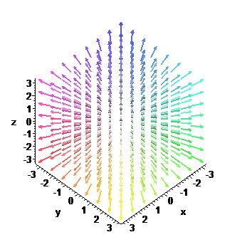

In the previous command, the components of the vector field are placed in brackets, the next two parameters specify the x, y and z axis ranges (-3..3) of where the vectors will be plotted, thickness = 2 specifies the how thick the arrows are (can be either 1, 2, 3), arrows specifies how the arrow style (can be LINE, THIN, SLIM and THICK with THIN being the default), and axes specifies that a FRAMED axes with be used (can be BOXED, FRAMED, NORMAL, or NONE).

█

