**Installing and Running Cisco VPN Client**

Cisco VPN client allows you to connect to the RU campus network and use RU software when working off campus. A little more information about it can be found at the link

<https://php.radford.edu/~knowledge/lore/article.php?id=186>

To install it, first go to the link

<https://ru-portal.portal.radford.edu/rusoftware/Login.aspx>

You should see a page that looks like the following, which you should login using your normal RU userid and password.

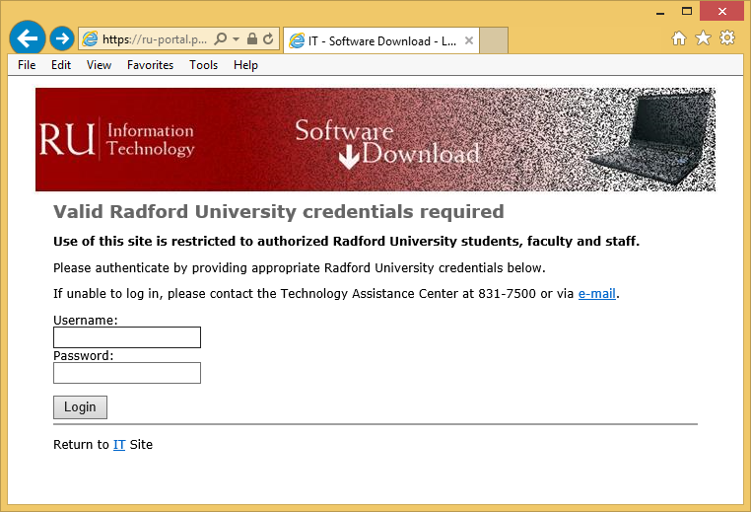

Next, select your operating system.

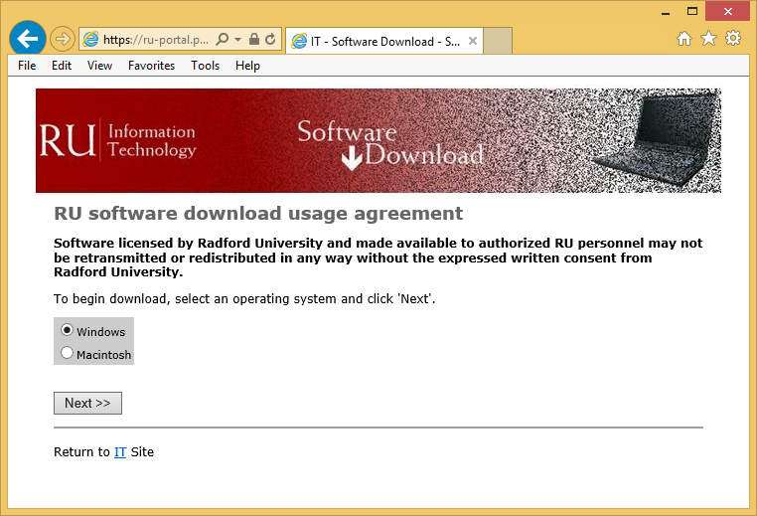

Depending on your selection, you should be taken to one of these two pages. Click on Cisco VPN Client link to download to installer for the program.

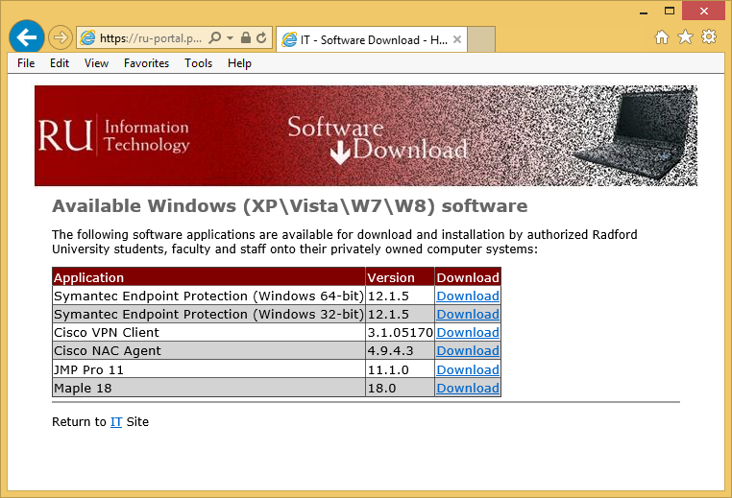 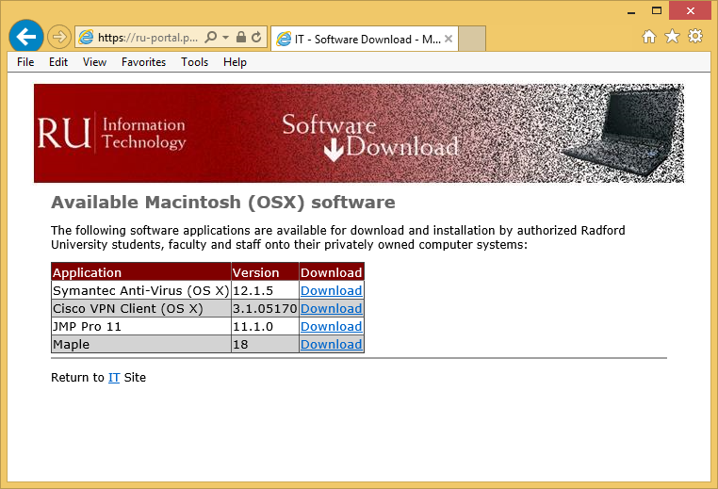

After downloading the installation file, run it. You should see a window similar to this. Select Next.

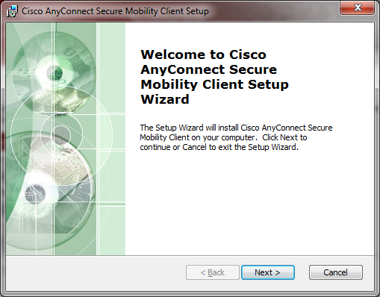

Next, accept the terms of the license agreement and select Next.

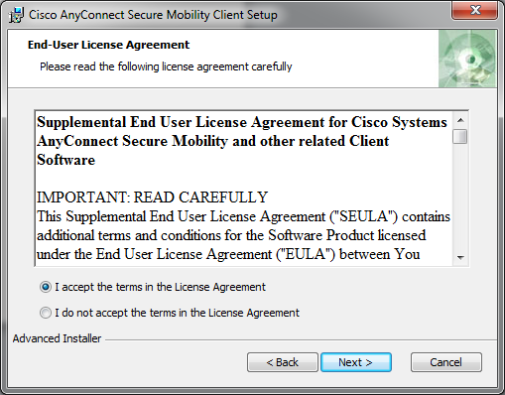

Click Install in the next window.

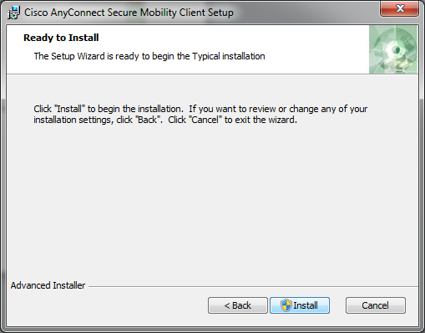

You should see a window looking something like this during the installation.

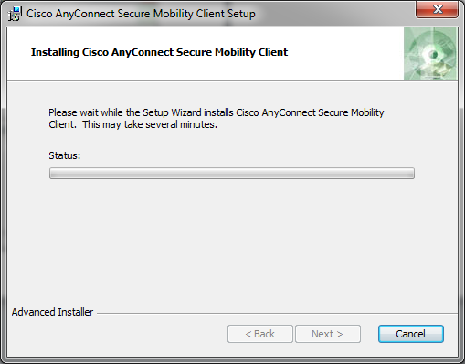

This should complete the installation.

To run the Cisco VPN software, you should look for a program now on your computer named Cisco AnyConnect Secure Mobility Client. Here is what the search window looks like on a Windows 7 machine.

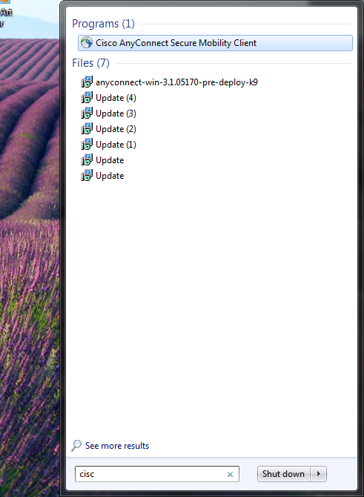

Once you start the software, you should see a window similar to the following (if the textbox is blank, type in **webvpn.radford.edu**). Click Connect.

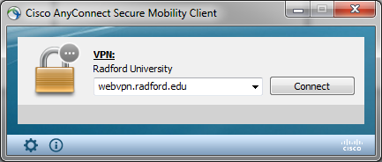

Log in using your normal RU userid and password.

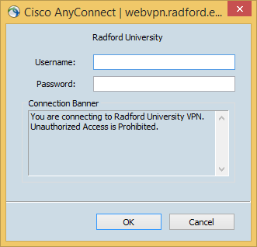

Click Accept in the following window to complete the login process.

