Section 2.5: Polyalphabetic Substitutions

Practice HW (not to hand in)
From the Barr Text
p. 118 # 1-6

In the monoalphabetic ciphers (shift, affine, substitution) we have looked at so far, we have always replaced a single plaintext letter with the same ciphertext letter. This makes this cipher highly vulnerable to frequency analysis. To increase security, we can change the cipher alphabet as we are enciphering the message. The following example illustrates an elementary method for doing this:

Example 1: Suppose we use the substitution
Plain | A | B | C | D | E | F | G | H | I | J | K | L | M | N | O | P | Q | R | S | T | U | V | W | X | Y | Z
Cipher | E | F | G | H | I | J | K | L | M | N | O | P | Q | R | S | T | U | V | W | X | T | Z | A | B | C | D

to encipher the odd letters of a message (first, third, fifth, etc. ) and
Plain | A | B | C | D | E | F | G | H | I | J | K | L | M | N | O | P | Q | R | S | T | U | V | W | X | Y | Z
Cipher | H | I | J | K | L | M | N | O | P | Q | R | S | T | U | V | W | X | Y | Z | A | B | C | D | E | F | G

to encipher the even letters of a message (second, fourth, sixth, etc.). Use this scheme to encipher the message “HELLO THERE HENRY” and comment on why this cipher is no longer monoalphabetic.

Solution: Using the first table for odd letters and the second table for even letters, we obtain

H | E | L | L | O | T | H | E | R | E | H | E | N | R | Y
L | L | P | S | S | A | L | L | V | L | L | L | R | Y | C

Hence, the ciphertext is “LLPSSALLVLLLRYC”. In monoalphabetic ciphers, each plaintext letter always enciphers to the same ciphertext letter. However, in this cipher, this is no longer true. For example, note that the letter L enciphers as the letter P and the letter S and R enciphers as V and Y. This type of cipher is an example of a type of cipher
we define next as a polyalphabetic cipher. █

Definition: A polyalphabetic cipher is a cipher where different substitution alphabets are used for various parts of the plaintext message.

Examples of Polyalphabetic Ciphers

1. Alberti Cipher Disk – p. 7 of the Barr text.

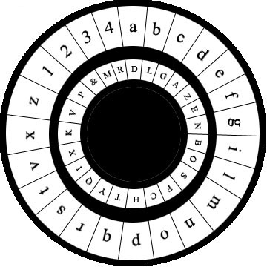

2. Thomas Jefferson Cipher Wheel – p. 15, p. 115 of the Barr text.

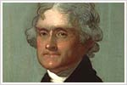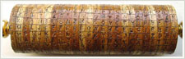

3. German Enigma cipher machine used in World War II – p. 23-25 of the Barr text.

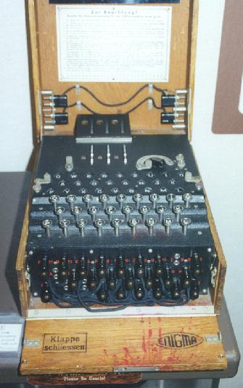

4. Vigenere Cipher.

Vigenere Cipher

The Vigenere Cipher is a polyalphabetic cipher invented by the Frenchman Blaise de
Vigenere Cipher in 1585.

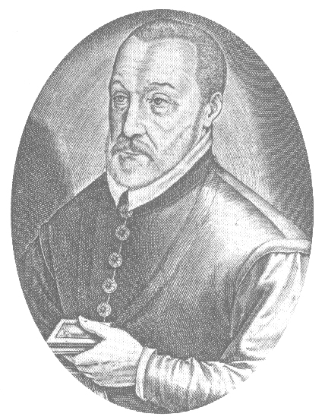

Picture of Blaise de Vigenere

However, the value of this cipher was not known until frequency analysis was used to break monoaphabetic ciphers. As a result, this cipher was not used widely until the 1800’s.

Enciphering Messages with the Vigenere Cipher

Correspondents agree on a keyword. The sender repeatedly writes the keyword below the plaintext, one keyletter beneath each plaintext letter. The cipher letter is found by finding the letter in the Vigenere cipher square where the column headed by the plaintext letter intersects the row labeled by the keyletter.

Example 2: Use the keyword “TRIXIE” to encipher “HAVING A PET CAN MAKE YOU MORE HAPPY” using the Vigenere cipher.

Solution: Using the cipher square gives the following:

Plaintext | H | A | V | I | N | G | A | P | E | T | C | A | N | M | A
Keyword | T | R | I | X | I | E | T | R | I | X | I | E | T | R | I
Ciphertext | A | R | D | F | V | K | T | G | M | Q | K | E | G | D | I

Plaintext | K | E | Y | O | U | M | O | R | E | H | A | P | P | Y
Keyword | X | I | E | T | R | I | X | I | E | T | R | I | X | I
Ciphertext | H | M | C | H | L | U | L | Z | I | A | R | X | M | G

Hence, the ciphertext is “ARDFV KTBMQ KEGDI HMCHL ULZIA RXMG”.
█

Deciphering Messages with the Vigenere Cipher

Recipient first writes the keyword repeatedly above the ciphertext. For each key-ciphertext pair, find the row in the Vigenere cipher square labeled with the keyletter and then the ciphertext letter in that row. The plaintext letter appears at the head of the column in which the ciphertext letter sits.

Example 3: Suppose the keyword “SYLVESTER” was used to encipher the message “VMRNG SMWSA PONEF WIMWL ADKKV EEEYV ZRAVI GWR D”. Decipher this message.

Solution: Writing the keyword above the ciphertext yields the following table:

Keyword | S | Y | L | V | E | S | T | E | R | S | Y | L | V | E | S
Ciphertext | V | M | R | N | G | S | M | W | S | A | P | O | N | E | F
Plaintext | D | O | G | S | C | A | T | S | B | I | R | D | S | A | N

Keyword | T | E | R | S | Y | L | V | E | S | T | E | R | S | Y | L
Ciphertext | W | I | M | W | L | A | D | K | K | V | E | E | E | Y | V
Plaintext | D | E | V | E | N | P | I | G | S | C | A | N | M | A | K

Keyword | V | E | S | T | E | R | S | Y | L
Ciphertext | Z | R | A | V | I | G | W | R | D
Plaintext | E | N | I | C | E | P | E | T | S

Hence, the plaintext is “DOGS CATS BIRDS AND EVEN PIGS CAN MAKE NICE PETS”. █

Note: If you know the plaintext and ciphertext of a message, you can recover the keyword by finding the ciphertext letter under the column of the corresponding plaintext letter. The keyword letter will be the one that sits in the row of the ciphertext letter.

Example 4: Determine the six-letter keyword that will decipher “EVVGOW” as “TVDOGS”.

Solution: Using the cipher square after writing down the plaintext and ciphertext yields:

Plaintext | T | V | D | O | G | S
Ciphertext | E | V | V | G | O | W
Keyword | L | A | S | S | I | E

Hence, the keyword is “LASSIE”. █

Vigenere Cipher Square

Plain
 | A | B | C | D | E | F | G | H | I | J | K | L | M | N | O | P | Q | R | S | T | U | V | W | X | Y | Z
A | A | B | C | D | E | F | G | H | I | J | K | L | M | N | O | P | Q | R | S | T | U | V | W | X | Y | Z
B | B | C | D | E | F | G | H | I | J | K | L | M | N | O | P | Q | R | S | T | U | V | W | X | Y | Z | A
C | C | D | E | F | G | H | I | J | K | L | M | N | O | P | Q | R | S | T | U | V | W | X | Y | Z | A | B
D | D | E | F | G | H | I | J | K | L | M | N | O | P | Q | R | S | T | U | V | W | X | Y | Z | A | B | C
E | E | F | G | H | I | J | K | L | M | N | O | P | Q | R | S | T | U | V | W | X | Y | Z | A | B | C | D
F | F | G | H | I | J | K | L | M | N | O | P | Q | R | S | T | U | V | W | X | Y | Z | A | B | C | D | E
G | G | H | I | J | K | L | M | N | O | P | Q | R | S | T | U | V | W | X | Y | Z | A | B | C | D | E | F
H | H | I | J | K | L | M | N | O | P | Q | R | S | T | U | V | W | X | Y | Z | A | B | C | D | E | F | G
I | I | J | K | L | M | N | O | P | Q | R | S | T | U | V | W | X | Y | Z | A | B | C | D | E | F | G | H
J | J | K | L | M | N | O | P | Q | R | S | T | U | V | W | X | Y | Z | A | B | C | D | E | F | G | H | I
K  Key | K | L | M | N | O | P | Q | R | S | T | U | V | W | X | Y | Z | A | B | C | D | E | F | G | H | I | J
L | L | M | N | O | P | Q | R | S | T | U | V | W | X | Y | Z | A | B | C | D | E | F | G | H | I | J | K
M | M | N | O | P | Q | R | S | T | U | V | W | X | Y | Z | A | B | C | D | E | F | G | H | I | J | K | L
N | N | O | P | Q | R | S | T | U | V | W | X | Y | Z | A | B | C | D | E | F | G | H | I | J | K | L | M
O | O | P | Q | R | S | T | U | V | W | X | Y | Z | A | B | C | D | E | F | G | H | I | J | K | L | M | N
P | P | Q | R | S | T | U | V | W | X | Y | Z | A | B | C | D | E | F | G | H | I | J | K | L | M | N | O
Q | Q | R | S | T | U | V | W | X | Y | Z | A | B | C | D | E | F | G | H | I | J | K | L | M | N | O | P
R | R | S | T | U | V | W | X | Y | Z | A | B | C | D | E | F | G | H | I | J | K | L | M | N | O | P | Q
S | S | T | U | V | W | X | Y | Z | A | B | C | D | E | F | G | H | I | J | K | L | M | N | O | P | Q | R
T | T | U | V | W | X | Y | Z | A | B | C | D | E | F | G | H | I | J | K | L | M | N | O | P | Q | R | S
U | U | V | W | X | Y | Z | A | B | C | D | E | F | G | H | I | J | K | L | M | N | O | P | Q | R | S | T
V | V | W | X | Y | Z | A | B | C | D | E | F | G | H | I | J | K | L | M | N | O | P | Q | R | S | T | U
W | W | X | Y | Z | A | B | C | D | E | F | G | H | I | J | K | L | M | N | O | P | Q | R | S | T | U | V
X | X | Y | Z | A | B | C | D | E | F | G | H | I | J | K | L | M | N | O | P | Q | R | S | T | U | V | W
Y | Y | Z | A | B | C | D | E | F | G | H | I | J | K | L | M | N | O | P | Q | R | S | T | U | V | W | X
Z | Z | A | B | C | D | E | F | G | H | I | J | K | L | M | N | O | P | Q | R | S | T | U | V | W | X | Y

