Installing Maple 10 on Windows Vista
The following document is designed to help guide you through the process of installing the older version of Maple 10 on the Windows Vista operating system (Maple 11 should install normally).
IMPORTANT!! Before attempting installation, make sure that you have Internet access and that nothing like Clean Access is blocking your Internet access.
After installing the Maple 10 disk, you should get a window similar to what is below. The key here is to NOT to run the InstallMaple10.exe file yet. You want to access the files on the disk. Click or double click Open folder to view files
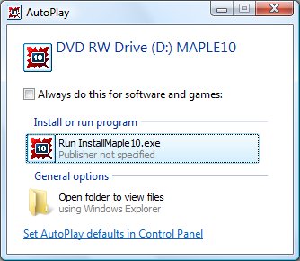
Next, you will be taken to screen to view your files (maybe similar to the figure below). You want to double click on the Windows folder.
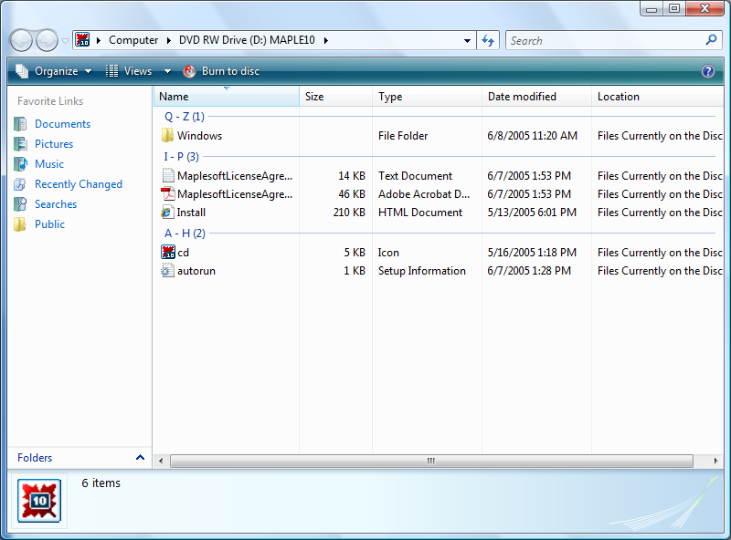

You should see a window that looks something like this. Now, double click on Disk1.
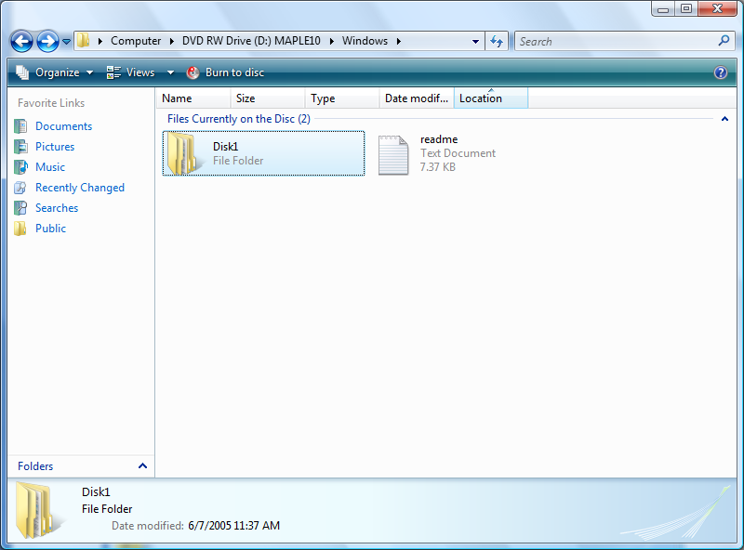

From the window looking like this, double click on InstData.
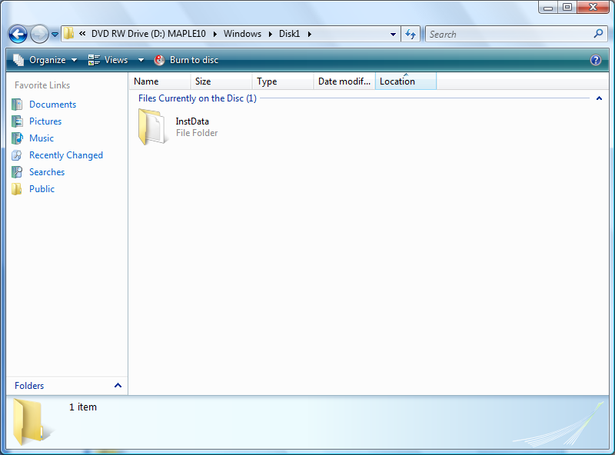

Your next window should look something like this. Double click on the folder entitled VM.
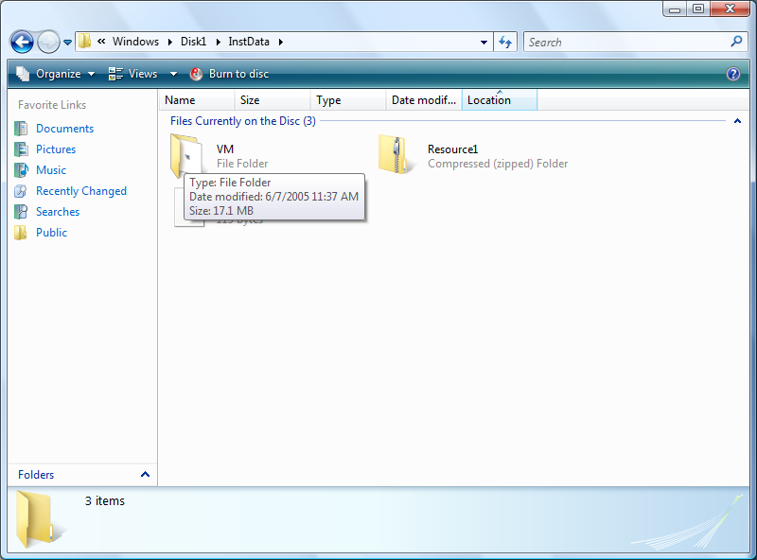

You should now see the window that contains the InstallMaple10.exe file. DO NOT double click on this yet!! You want to rightclick on this file icon and pull down and select Properties.
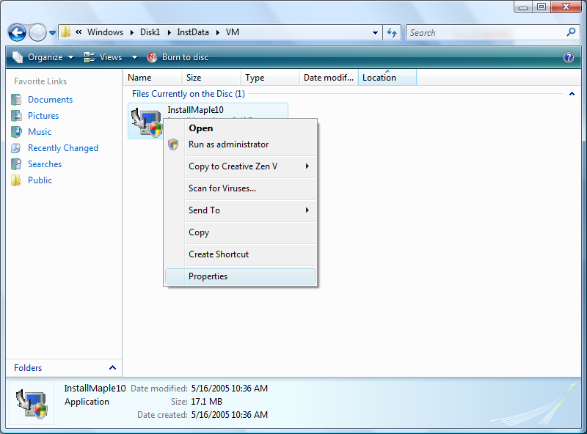

You will get a window that looks like the following (once it comes up, click the Compatibility tab at the top). In this window, you want to check the Run this program in compatibility mode for and select Windows 2000. Also, in this window, if possible, check the Run this program as an administrator at the bottom (if you are not allowed to, do not worry about it). Then click Apply. The click OK to exit the window.
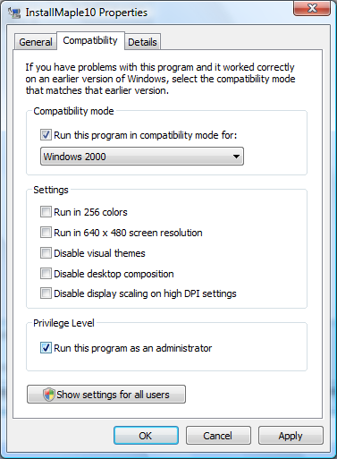
You should be taken back to the window below. Now, we are ready to install Maple 10. You want to go ahead and double click on the InstallMaple10 icon to begin the installation.
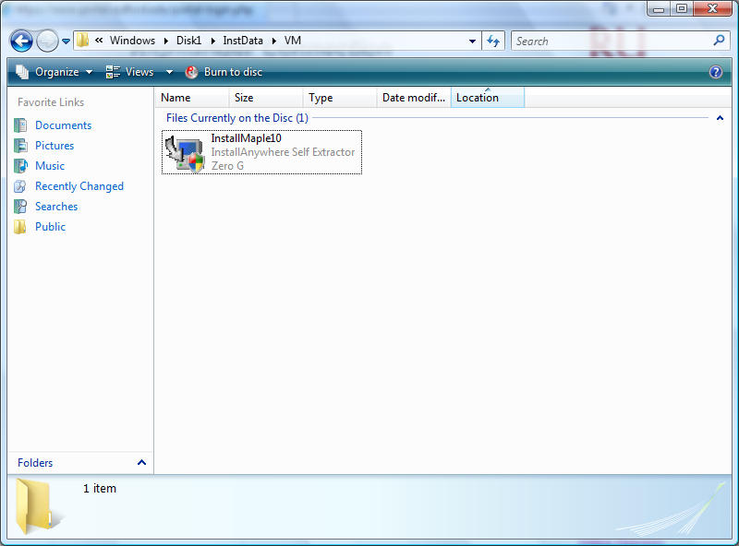
After waiting a bit, you should get a screen that looks like this. Just click Next
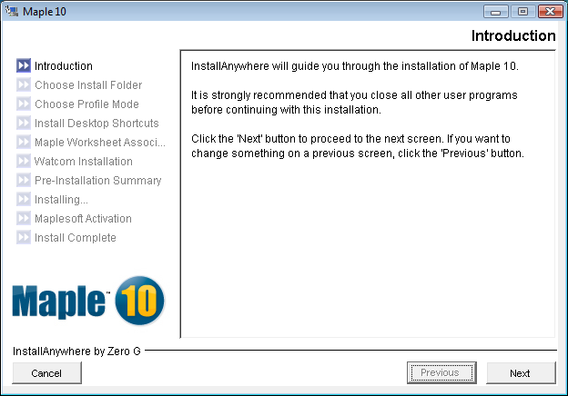

You will now get this screen. Just click Next.
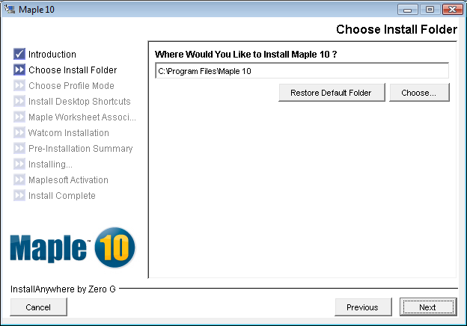

You will now get this screen. Just keep Single-user Profile selected and click Next.
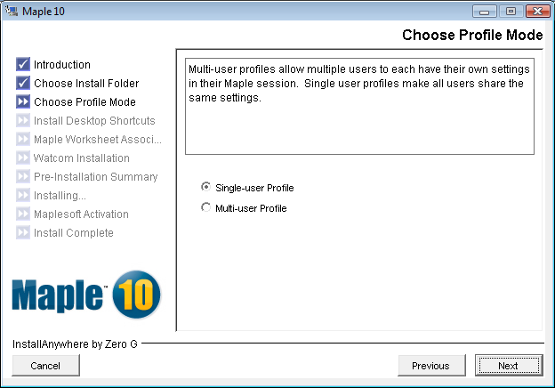

You will now get this screen. Just keep Yes selected and click Next.
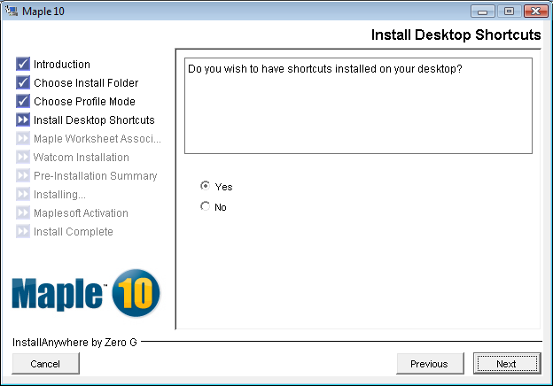

You will now get this screen. Just keep Yes selected and click Next.
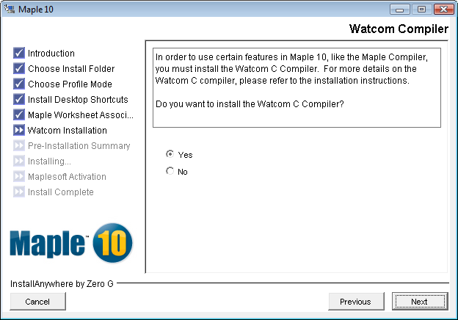

You will now get this screen. Don’t change anything and click Next.
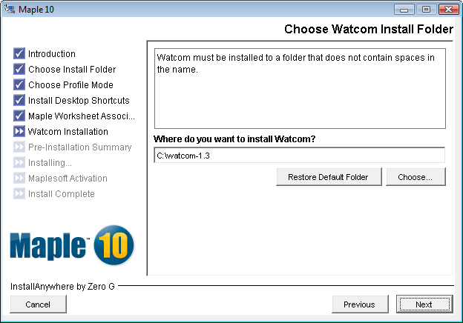

You will now get this screen. Click Install.
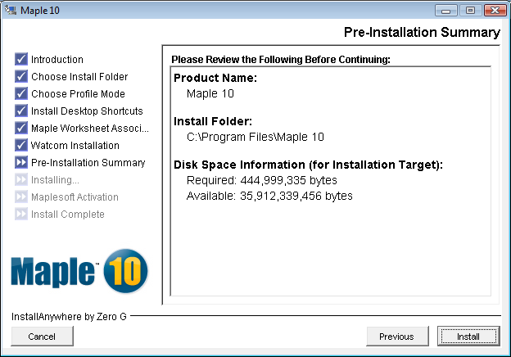

After a wait you will now get this screen. Keep Activate selected and click Next.
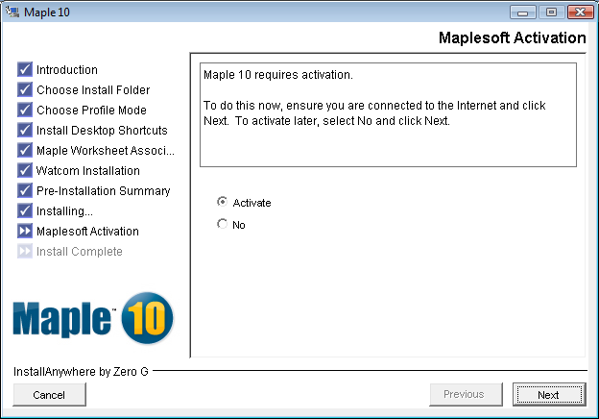

You will now get this screen. Just click Next.
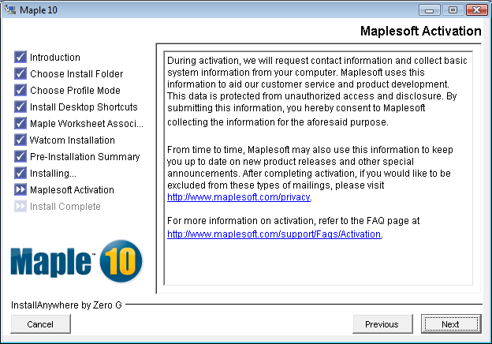

Now, you much enter your Purchase Code. This should be located on the inner sleeve of the booklet your Maple 10 disk came with. Go ahead and enter your purchase code and click Next.
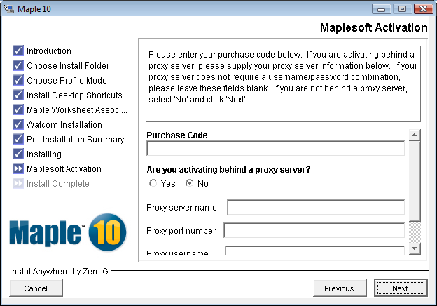
You should now come to a screen that looks like this (your purchase code should be in the box). Fill in the information required in red and click Next.
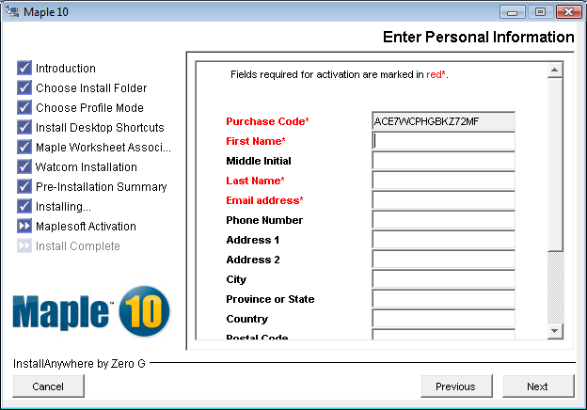

You should now see window indicating your activation was successful. Just click OK.

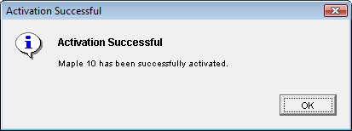

You will now see a Window telling that Maple 10 has been successfully installed. It turns out you don’t have to restart the system to get Maple to work (although it is okay too). You can click No, I will restart the system myself and do it later.
