Section 2.8: Cryptanalysis of the Vigenere Cipher Using Signatures and Scrawls

To break and decrypt a message that was enciphered using the Vigenere cipher, we must determine the keyword used to encipher the message. The Friedman and Kasiski test only give an estimate of the keyword length. Neither method gives a way of determining the actual keyword itself. The techniques described here will not only provide another way to estimate the probable keyword length but will also give a way of actually determining the keyword. The method described here was originated by Charles Babbage in 1954. We first show how the Vigenere cipher can be described mathematically.

1. Mathematical Description of the Vigenere Cipher and Cosets

Fact: When a plaintext letter is enciphered using a keyword letter, the effect when enciphering a message using the Vigenere cipher square is to add the MOD 26 alphabet representation of the plaintext letter and the keyword letter to obtain a number which is the MOD 26 alphabet representation of the ciphertext letter number.

Example 1: Suppose we encipher the message “DOGS” using the keyword “PETS” with the Vigenere cipher square:
Plaintext | D | O | G | S
Keyword | P | E | T | S
Ciphertext | S | S | Z | K

The ciphertext “SSZK” can be obtained mathematically using the MOD 26 alphabet table as follows:

1st Letter: $\begin{matrix}D & ⇒ & 3 & ⋱ \\ P & ⇒ & \text{15} & ⋰\end{matrix}(3+\text{15})\text{MOD}\text{26}=\text{18}\text{MOD}\text{26}=\text{18}⇒S$

2nd Letter: $\begin{matrix}O & ⇒ & \text{14} & ⋱ \\ E & ⇒ & 4 & ⋰\end{matrix}(\text{14}+4)\text{MOD}\text{26}=\text{18}\text{MOD}\text{26}=\text{18}⇒S$

3rd Letter: $\begin{matrix}G & ⇒ & 6 & ⋱ \\ T & ⇒ & \text{19} & ⋰\end{matrix}(6+\text{19})\text{MOD}\text{26}=\text{25}\text{MOD}\text{26}=\text{25}⇒Z$

4th Letter: $\begin{matrix}S & ⇒ & \text{18} & ⋱ \\ S & ⇒ & \text{18} & ⋰\end{matrix}(\text{18}+\text{18})\text{MOD}\text{26}=\text{36}\text{MOD}\text{26}=\text{10}⇒K$ ▄▄

We can build on this idea to help cryptanalyze the Vigenere cipher. A first major step in trying to find the keyword used by a Vigenere cipher is to find its length (the number of letters it has). We now illustrate why just knowing the keyword length can be very valuable in breaking a message encipher using the Vigenere cipher.

Fact: Each individual keyword letter forms a shift cipher. The letters in each individual shift cipher form a coset.

The following example illustrates this what this fact means.

Example 2: Suppose we want to encipher “DOGS AND CATS ARE NICE” using the keyword “PET” with a Vigenere cipher. The following is a result of what the using the cipher square would obtain:

Plaintext | D | O | G | S | A | N | D | C | A | T | S | A | R | E | N | I | C | E
Keyword | P | E | T | P | E | T | P | E | T | P | E | T | P | E | T | P | E | T
Cipher | S | S | Z | H | E | G | S | G | T | I | W | T | G | I | G | X | G | X
Consider the letters enciphered by the letter P (in bold). The claim here is that the letter P just performs a shift cipher of length 15 on the letters it enciphers (the letters D, S, D, T, R, and I). To see this, one can perform computations using the keyletter P similar to Example 1 given above.

1st P: $\begin{matrix}D & ⇒ & 3 & ⋱ \\ P & ⇒ & \text{15} & ⋰\end{matrix}(3+\text{15})\text{MOD}\text{26}=\text{18}\text{MOD}\text{26}=\text{18}⇒S$

2nd P: $\begin{matrix}S & ⇒ & \text{18} & ⋱ \\ P & ⇒ & \text{15} & ⋰\end{matrix}(\text{18}+\text{15})\text{MOD}\text{26}=\text{33}\text{MOD}\text{26}=7⇒H$

3rd P: $\begin{matrix}D & ⇒ & 3 & ⋱ \\ P & ⇒ & \text{15} & ⋰\end{matrix}(3+\text{15})\text{MOD}\text{26}=\text{18}\text{MOD}\text{26}=\text{18}⇒S$

4th P: $\begin{matrix}T & ⇒ & \text{19} & ⋱ \\ P & ⇒ & \text{15} & ⋰\end{matrix}(\text{19}+\text{15})\text{MOD}\text{26}=\text{34}\text{MOD}\text{26}=8⇒I$

5th P: $\begin{matrix}R & ⇒ & \text{17} & ⋱ \\ P & ⇒ & \text{15} & ⋰\end{matrix}(\text{17}+\text{15})\text{MOD}\text{26}=\text{32}\text{MOD}\text{26}=6⇒G$

6th P: $\begin{matrix}I & ⇒ & 8 & ⋱ \\ P & ⇒ & \text{15} & ⋰\end{matrix}(8+\text{15})\text{MOD}\text{26}=\text{23}\text{MOD}\text{26}=\text{23}⇒X$

The resulting cipher letters (D, S, D, T, R, and I) that the letter P (shift cipher of 15) produces is called the coset formed by P. Similarly we can see by looking at what is highlighted in the table

Plaintext | D | O | G | S | A | N | D | C | A | T | S | A | R | E | N | I | C | E
Keyword | P | E | T | P | E | T | P | E | T | P | E | T | P | E | T | P | E | T
Cipher | S | S | Z | H | E | G | S | G | T | I | W | T | G | I | G | X | G | X

that the letter E produces a shift cipher of 4 on the plaintext letters it enciphers and gives the coset S, E, G, W, I, and G. Finally, the third coset is produced by the letter T (shift cipher of 19) and gives the coset Z, G, T, T, G, and X. ▄▄

Fact: The number of cosets formed gives the keyword length (the keyword’s number of letters). Thus, the 3 cosets we had in the last example corresponded to the fact that the keyword (PET) has 3 letters.

If we know the keyword length and it is reasonably short, we can do a frequency analysis using Maple on the individual coset shift ciphers and try to randomly put together a keyword that fits. The next example sets up the preliminaries for illustrating this fact.

Example 3: Suppose the message “QELHI MWSNC HWDKL PVXJW NPPEN GTAQT CHYGM XCHEN MGSIF TEGDV TCHTG IZDSW EIMHJ HGGAX PWGIG” was enciphered with a Vigenere cipher where we know that the keyword is of length 3 (three letters long). We will illustrate in class how we can use this knowledge to break this message. ▄▄

If the keyword length is reasonably short, example 3 shows how we can by determine the keyword. However, this method becomes more challenging if the keyword becomes longer. The next sections illustrate how this problem can be overcome.

2. Using Signatures to Determine Keyword Length in the Vigenere Cipher

We first define the definition of the English Signature and the Sample Signature

Signature of English: Gives a plot of the probabilities of printed standard English plotted in increasing sorted order (from smallest to largest).

Recall the following table for the standard English frequencies:

Letter | Probability of Occuring |  |  | Letter | Probability of Occuring
A | 0.08167 |  |  | N | 0.06749
B | 0.01492 |  |  | O | 0.07507
C | 0.02782 |  |  | P | 0.01929
D | 0.04253 |  |  | Q | 0.00095
E | 0.12702 |  |  | R | 0.05987
F | 0.02228 |  |  | S | 0.06327
G | 0.02015 |  |  | T | 0.09056
H | 0.06094 |  |  | U | 0.02758
I | 0.06966 |  |  | V | 0.00978
J | 0.00153 |  |  | W | 0.02360
K | 0.00772 |  |  | X | 0.00150
L | 0.04025 |  |  | Y | 0.01974
M | 0.02406 |  |  | Z | 0.00074

Table 1: Frequency of Letters in Standard English

Figure 1 gives a plot generated from Maple of the English signature frequencies given in Table 1:

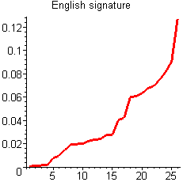
Figure 1: English signature plot

Signature of the Sample: Gives the signature plot of the probability frequencies of a sample of letters (much smaller than the whole English language) in increasing sorted order. An example would be a sample plaintext or ciphertext message.

Facts about the Signature of a Sample
1. Since a sample contains only a small number of letters, it is likely some letters will not be included in the
sample at all – their probabilities will be 0.
2. Because a list of probabilities of all letters (in an English signature or Sample signature) must sum to 1,
some letters in the sample signature will have higher probabilities than in the English signature to
compensate for the letters with probability of 0.
3. Hence, the sample signature curve should be lower than the English signature for smaller occurring
frequencies and larger for higher occurring frequencies.
4. Since a monoalphabetic cipher (examples are shift, affine, and substitution) preserves frequencies from a
plaintext message to its corresponding ciphertext message, the sample signature of the plaintext message
will be the same as a ciphertext.

The following example illustrates these facts.

Example 3: Suppose we have the message "WE WANT TO LOOK AT THE SIGNATURE OF THE SAMPLE OF A MESSAGE". Using Maple, we can generate the Table 2 which gives the probability frequencies of the letters in this sample plaintext.

Letter | Probability of Occuring |  |  | Letter | Probability of Occuring
A | 6/47 = 0.1276595745 |  |  | N | 2/47 = 0.04255319149
B | 0 |  |  | O | 5/47 = 0.1063829787
C | 0 |  |  | P | 1/47 = 0.02127659574
D | 0 |  |  | Q | 0
E | 7/47 = 0.1489361702 |  |  | R | 1/47 = 0.02127659574
F | 2/47 = 0.04255319149 |  |  | S | 4/47 = 0.08510638298
G | 2/47 = 0.04255319149 |  |  | T | 6/47 = 0.1276595745
H | 2/47 = 0.04255319149 |  |  | U | 1/47 = 0.02127659574
I | 1/47 = 0.02127659574 |  |  | V | 0
J | 0 |  |  | W | 2/47 = 0.04255319149
K | 1/47 = 0.02127659574 |  |  | X | 0
L | 2/47 = 0.04255319149 |  |  | Y | 0
M | 2/47 = 0.04255319149 |  |  | Z | 0

Table 2: Frequency of Letters of given plaintext sample message

The following graph in Figure 2 illustrates how this sample signature generated using the frequencies in Table 1 compares with the signature of the English frequencies given in Table 2.

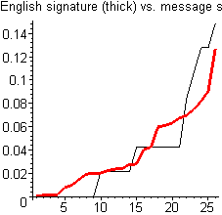

Figure 2: English signature vs. Sample signature for a plaintext message

Figure 2 illustrates how the sample signature is lower than the English for low frequency letters (some have 0 probabilities) but compensates by being above the English signature for higher occurring frequencies. This behavior is typical for sample signatures. ▄▄

It is important to note from fact 4 above that monoalphabetic ciphers preserves frequencies. This means that both the plaintext and ciphertext produced by a monoalphabetic cipher will have the same signature. The next example illustrates this point.

Example 4: Using the affine cipher $y=(\text{11}x+7)$MOD 26, we can show that the plaintext of Example 3 "WE WANT TO LOOK AT THE SIGNATURE OF THE SAMPLE OF A MESSAGE" will encipher as the message "PZPHU IIFYF FNHII GZXRV UHITM ZFKIG ZXHJQ YZFKH JZXXH VZ". Table 3 gives the frequency distribution of this ciphertext.

Letter | Probability of Occuring |  |  | Letter | Probability of Occuring
A | 0 |  |  | N | 1/47 = 0.02127659574
B | 0 |  |  | O | 0
C | 0 |  |  | P | 2/47 = 0.04255319149
D | 0 |  |  | Q | 1/47 = 0.02127659574
E | 0 |  |  | R | 1/47 = 0.02127659574
F | 5/47 = 0.1063829787 |  |  | S | 0
G | 2/47 = 0.04255319149 |  |  | T | 1/47 = 0.02127659574
H | 6/47 = 0.1276595745 |  |  | U | 2/47 = 0.04255319149
I | 6/47 = 0.1276595745 |  |  | V | 2/47 = 0.04255319149
J | 2/47 = 0.04255319149 |  |  | W | 4/47 = 0.08510638298
K | 2/47 = 0.04255319149 |  |  | X | 0
L | 0 |  |  | Y | 2/47 = 0.04255319149
M | 1/47 = 0.02127659574 |  |  | Z | 7/47 = 0.1489361702

Table 3: Frequency of Letters of given ciphertext sample message

We should note that the probability frequencies give in Table 2 and Table 3 are the same numbers just applied to different letters. Hence, the signature of the sample ciphertext will be exactly the same as the sample signature of the plaintext as comparing Figure 3 below with Figure 2 given above.

Figure 3: English signature vs. Sample signature for a ciphertext message

How can we use the concept of a signature to determine the length of the keyword used in a Vigenere cipher? Recall in the Vigenere cipher that each keyword letter performs a simple shift cipher. The ciphertext letters enciphered by each keyword letter form a coset. We can use this idea to obtain the keyword length using the following facts (next page):

1. Since each coset is formed by a simple shift cipher, its sample signature should behave like any sample
sample signature when compared to the English signature, that is, lower than the English signature for
letters of fewer occurring frequencies and then higher for letters of higher occurring frequencies.
2. The number of cosets is the same as the number of letters in the keyword. The number of cosets will be
number of sample signatures that best exhibit the standard behavior when compared to the English signature – lower than the English signature at first and higher later.

The following example illustrates these facts.

Example 5: Suppose we have received the message "LPOFE MYFSO KVKIZ GWVJR VNUEK BAQWV ZFLWS BJMLH DTEHF LKEKB GAVPU JKQMA SBAEW AGAVA IESER FUITO WCYRV BUQWB KEEQT RLPKX WGCBJ LRRFO ZUSVJ XWGCB JLAFW LOALP KIAOK AWZKP AXNRJ" that was enciphered with a Vigenere cipher. Figure 4 below compares the English signature with possibilities representing the signatures when a particular number of cosets occur.

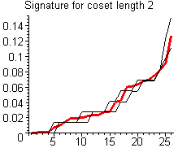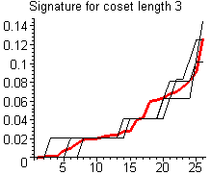

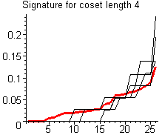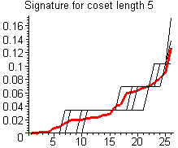

Figure 4: Comparison of English signatures with various possible coset (keyword) lengths.

Recall that each individual keyword letter in the Vigenere cipher produces each coset, which is simply a shift cipher. The coset length should be the graph whose cosets exhibit the best overall behavior when compared the the English signature, that is, the one whose coset signatures are close to zero and below the English signature to the left and are more overall above the English signature to the right. The graph with coset length of 4 best exhibits this behavior. This says there are 4 cosets and hence the number of letters in the keyword should be 4. ▄▄

Knowing the keyword length still does not tell us the keyword. The next section gives a method for doing this.

3. Determining The Keyword Using Scrawls

We first define the definition of a scrawl in general and then the English scrawl and Sample scrawl.

Scrawl – the graph of the probability distribution of letters in alphabetical order

Note a scrawl differs from a signature because a signature plots the probability in sorted increasing order. We now distinguish between the English and Sample scrawls

English Scrawl – the scrawl of the entire English language.

Sample Scrawl – the scrawl of a sample of English, like a plain or ciphertext message.

Figure 5 gives a graph of the scrawl of the standard English frequencies.

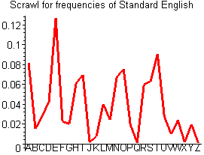

Figure 5: Graph representing scrawl for standard English

Facts about Scrawls

1. In shift ciphers, the scrawl of a sample ciphertext will “roughly” have the same appearance as the
English scrawl – except that it is shifted to the right. Recall that each keyword letter in the Vigenere
Cipher produces a simple shift cipher and forms a coset with each plaintext letter that it enciphers.
- For each coset produced by a keyword letter in the Vigenere cipher, we will use Maple to draw successive shifts (from 0 to 25) until we find the sample coset scrawl with the closest match with the English scrawl.
3. The alphabet letter in our MOD 26 alphabet assignment corresponding to the shift amount number found
in step 2 will be the keyword letter used in the Vigenere encipherment that we want.
4. Repeating step 3 for each coset will allow us to recover the entire keyword and decipher the message.

Example 6: Continuing Example 5 for the ciphertext

"LPOFE MYFSO KVKIZ GWVJR VNUEK BAQWV ZFLWS BJMLH DTEHF LKEKB GAVPU JKQMA SBAEW AGAVA IESER FUITO WCYRV BUQWB KEEQT RLPKX WGCBJ LRRFO ZUSVJ XWGCB JLAFW LOALP KIAOK AWZKP AXNRJ",

since we know the keyword is of length 4 letters, there are 4 cosets and we must compare the scrawls of each of these cosets with the English scrawl. Note that the 4 cosets for this message are

["LESKWVKWLJDFKVKSWVSUWVWELWJFSWJWLAWAJ", "PMOIVNBVWMTLBPQBAAEICBBQPGLOVGLLPOZX", "OYKZJUAZSLEKGUMAGIRTYUKTKCRZJCAOKKKN", "FFVGREQFBHHEAJAEAEFORQERXBRUXBFAIAPR"];
We will be looking for the sample scrawl for each coset that has the best “fit”. The shift amount to get that best fit corresponds to the keyword letter. The following graphs give comparisons for two shifts (there are actually 26 shift possibilities in all) where one shift will correspond to the keyword letter.

Keyword Letter 1

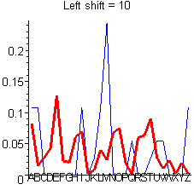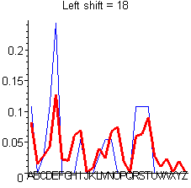

Keyword Letter 2

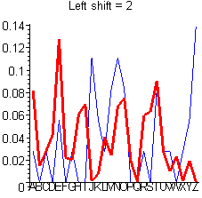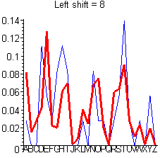

Keyword Letter 3

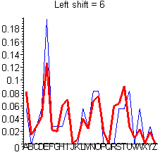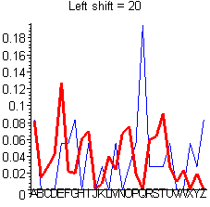

Keyword Letter 4

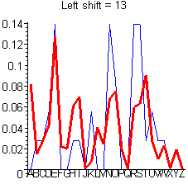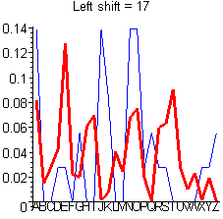

For each keyword letters, the shifts that have the best fit are 18, 8, 6, and 13. In the MOD 26 alphabet assignment, this corresponds to the keyword “SIGN”. Using the Vigenere Cipher Square, we can then decipher the original message

"LPOFE MYFSO KVKIZ GWVJR VNUEK BAQWV ZFLWS BJMLH DTEHF LKEKB GAVPU JKQMA SBAEW AGAVA IESER FUITO WCYRV BUQWB KEEQT RLPKX WGCBJ LRRFO ZUSVJ XWGCB JLAFW LOALP KIAOK AWZKP AXNRJ",

using this keyword as

"THIS MESSAGE IS INTENDED FOR STUDENTS TO MORE FULLY UNDERSTAND HOW SIGNATURES AND SCRAWLS CAN BE USED TO DETERMINE THE KEYWORD LENGTH AND KEYWORD USED IN THE VIGENERE CIPHER"

Exercises

1. From the following graphs of signatures of various coset lengths for a ciphertext enciphered using a Vigenere cipher, what would be the most likely keyword length? Explain your reasoning.

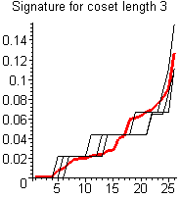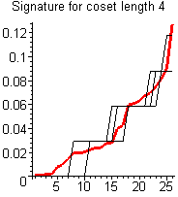

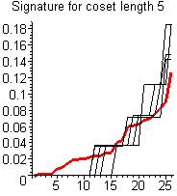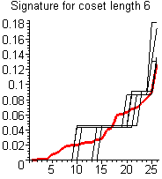

2. Suppose you have a Vigenere ciphertext where you have determined that the keyword
length is five. Comparing the two scrawls for each keyword letter from the graphs on
the next two pages, determine what the keyword would be.

Scrawls for Keyword Letter 1

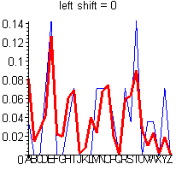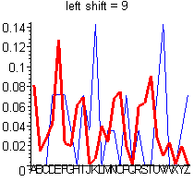

Scrawls for Keyword Letter 2

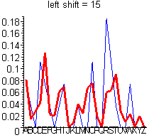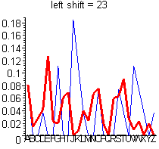

Scrawls for Keyword Letter 3

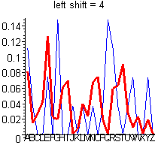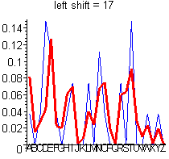

Scrawls for Keyword Letter 4

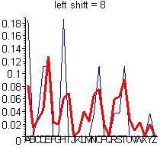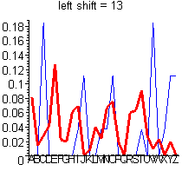

Scrawls for Keyword Letter 5

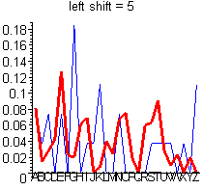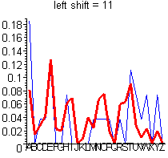

3. Using the keyword you found on the previous exercise (exercise 2), use the Vigenere Cipher
Square to decipher

AEIQW IHKPP LPJBQ UACUZ NIYWQ TWVAP MTJBP RPELH HTEBS ELVIE HTIAE AGKAE OVVBX URYVT CTI"

