**Steps for Activating Maplets from Personal Computer**

First, go to Citrix and access Maple

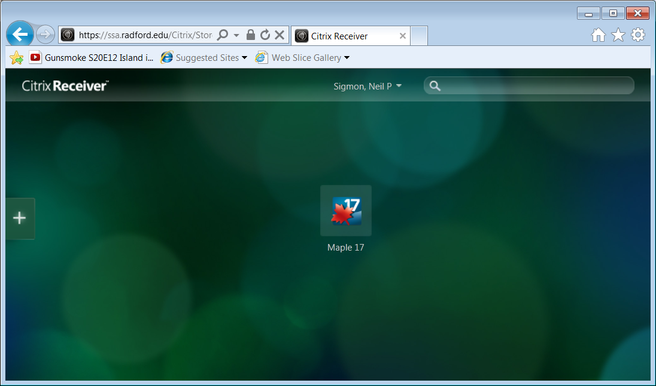

Once you double click on the Maple 17 icon and open Maple, you should get to a window similar to this:

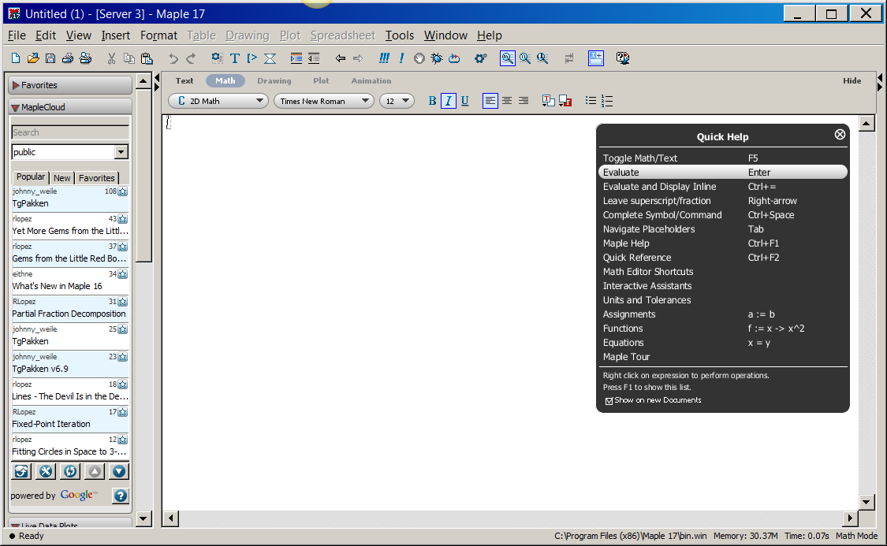

Now, select **File** and select **Open**



By default, you will see a screen that looks like this:

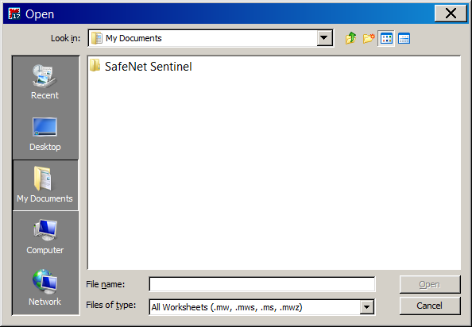

We need to go find the chapter and section location where the Maplet you want is stored. Here, we assume that the Maplets are stored somewhere on the C: Drive of the personal computer. To get to there, select the down arrow beside the My Documents textbox but look **carefully** at the following screenshot:

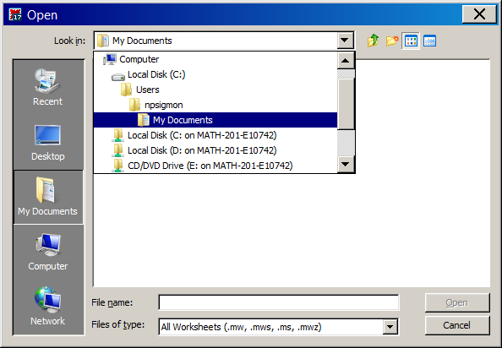

Unfortunately, there are two labeled C: drives which can cause confusion. The Local Disk (C:) is the local C drive on Citrix . Since we want to get to the C drive on a personal computer, this is not the one we want! You should select **Local Disk (C: on Math-201-E10742)**

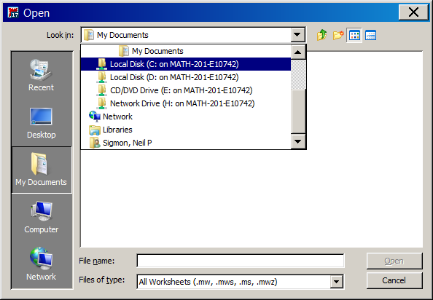

This should get you to a list of Files/Folders on your personal computer C Drive. Here is an example.

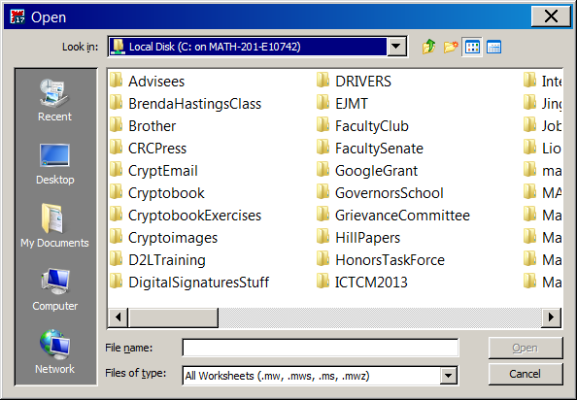

Next, go to the folder at the location you have stored your Maplets and select and click on this folder. For example:

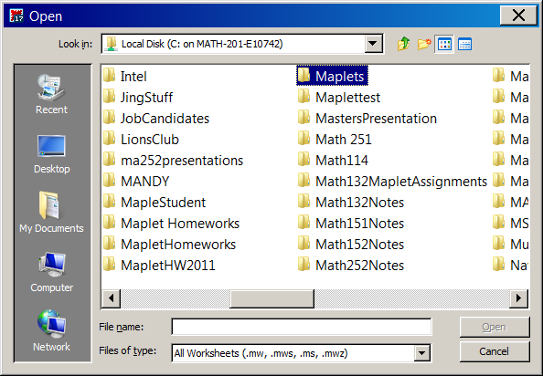

You should see a screen like this.

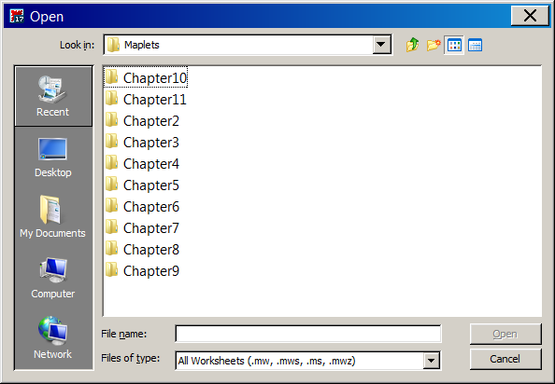

You then can go to the chapter folder and section to get the Maplet you want to use. This demonstrates how to go to Chapter 5, Section 5.4.

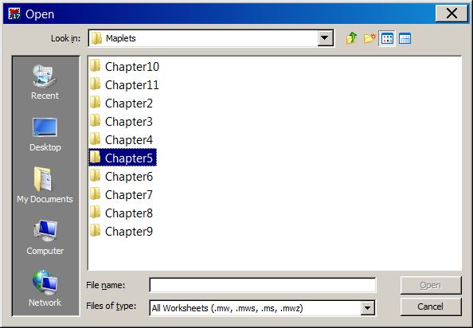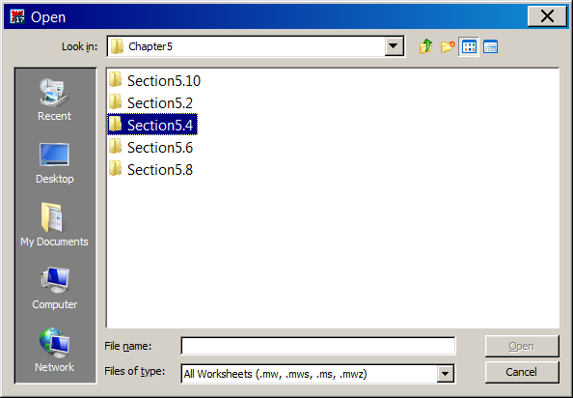

Once you get to the correct folder, you will notice that the name of the Maplet will not appear. That is because the wrong type of **File Type** has been selected.

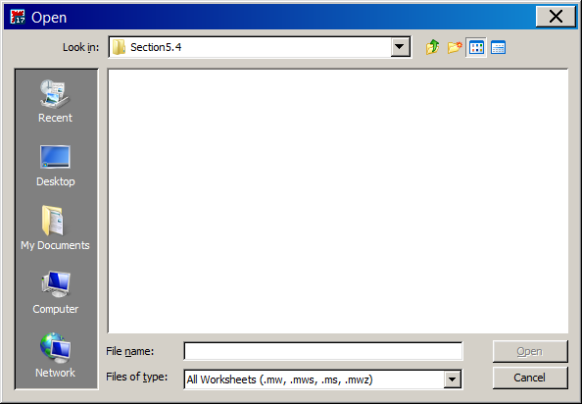

This can be fixed by going to the **Files of type** tab and selecting **Maplet (.maplet)**. The name of the desired Maplet will appear.

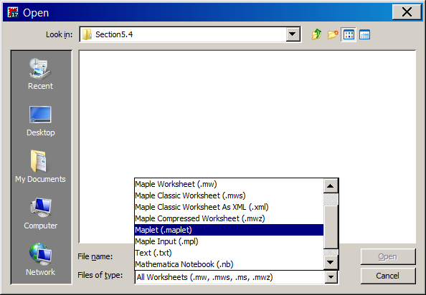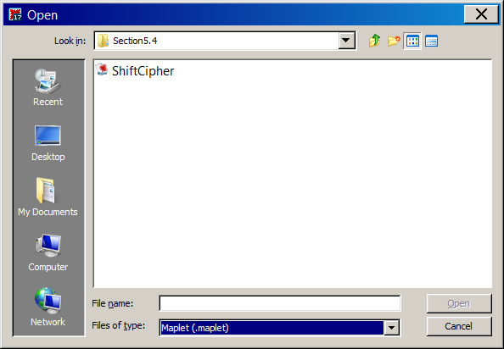

Next, select the Maplet you want and select **Open**.

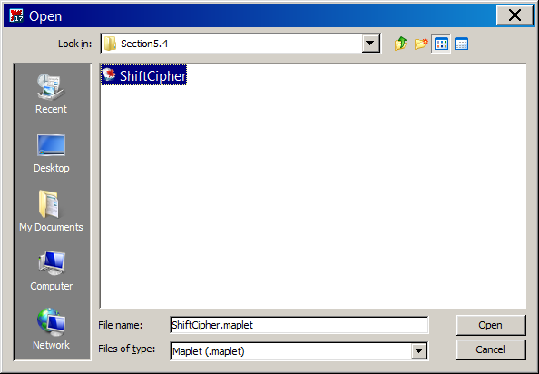

This will open the Maplet. You will see a lot of ugly looking Maple code, which you do not have to worry about. All you need to do is click the ***!!!*** tab!

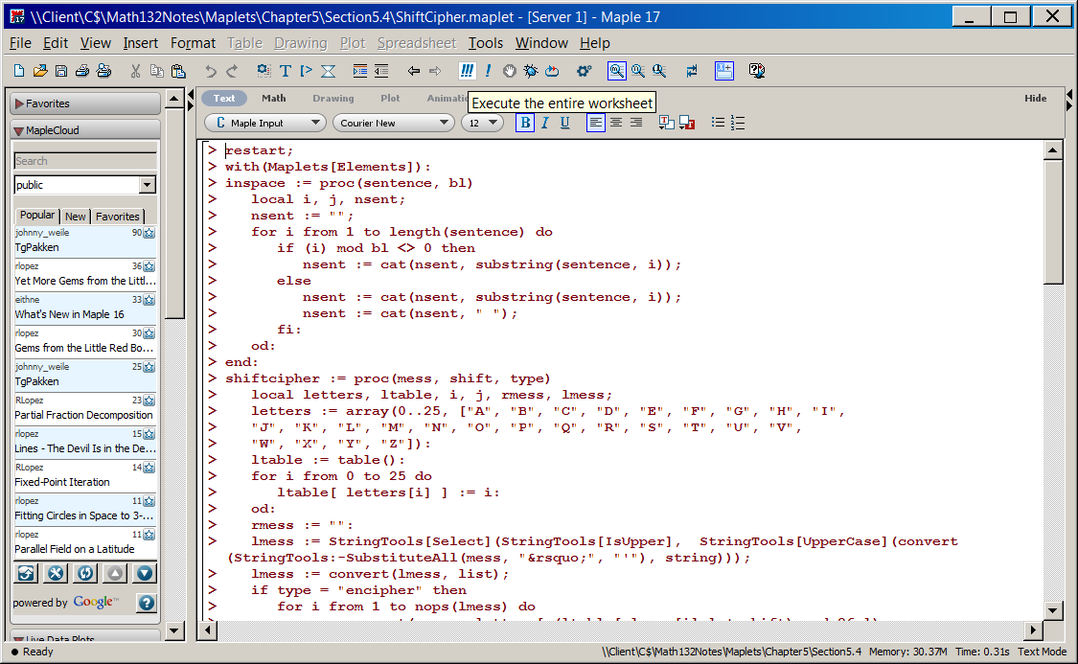

This will load in your Maple, and you are ready to get started.

