**Steps for Activating Maplets from Personal Laptop**

Make sure you have gone to the help desk in Heth 157 and the full working version of Maple 17 has been installed on your computer. Then, start Maple on your computer (the version on my machine is Maple 15 – yours will be Maple 17).

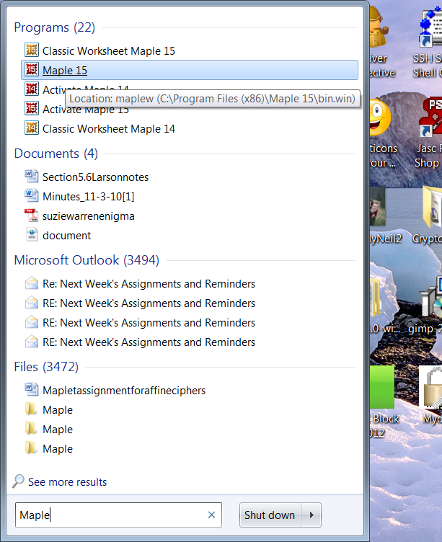

You should see a window similar to this:

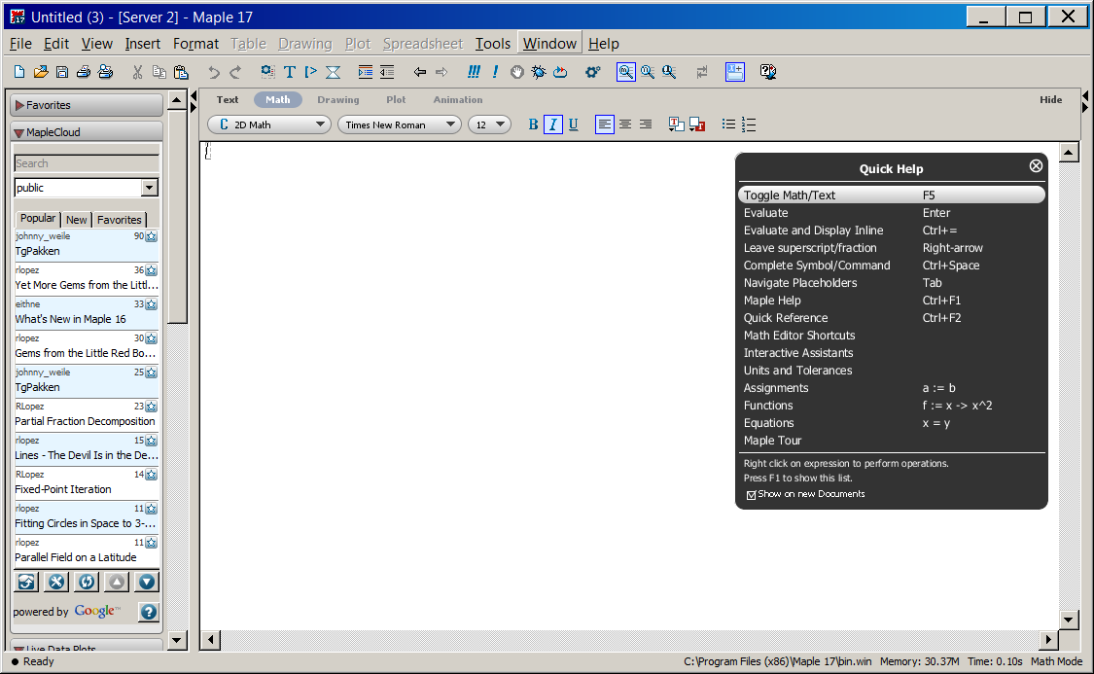

Now, select **File** and select **Open**



Now, using the **Look in** tab, go find the chapter and section location where the Maplet you want is stored.

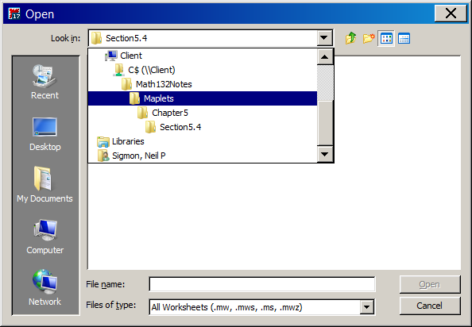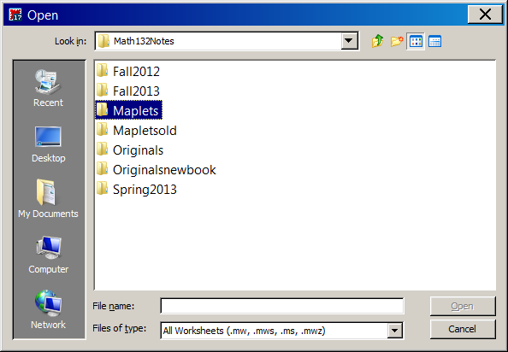

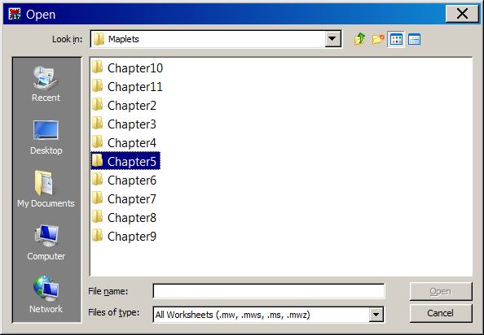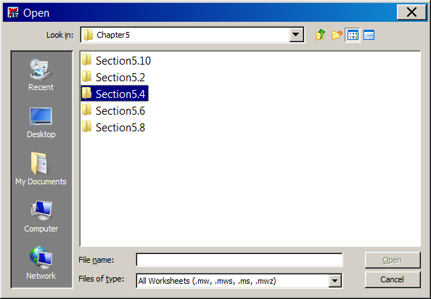

Once you get to the correct folder, you will notice that the name of the Maplet will not appear. That is because the wrong type of **File Type** has been selected.

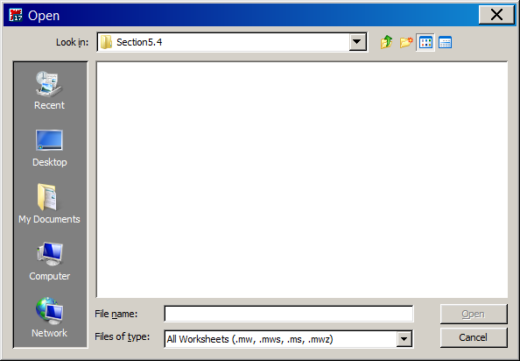

This can be fixed by going to the **Files of type** tab and selecting **Maplet (.maplet)**. The name of the desired Maplet will appear.

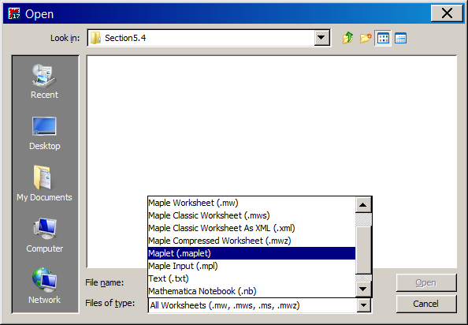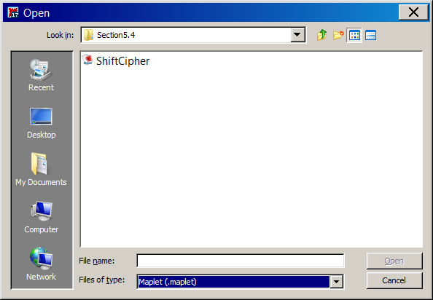

Next, select the Maplet you want and select **Open**.

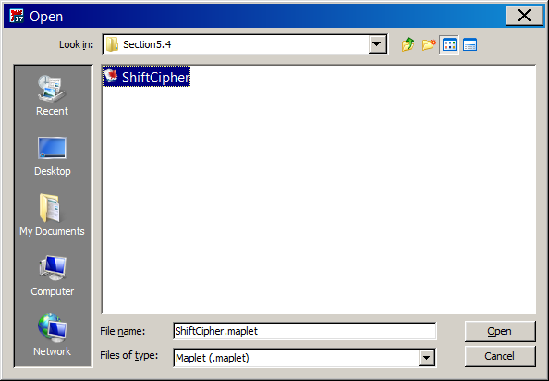

This will open the Maplet. You will see a lot of ugly looking Maple code, which you do not have to worry about. All you need to do is click the ***!!!*** tab!

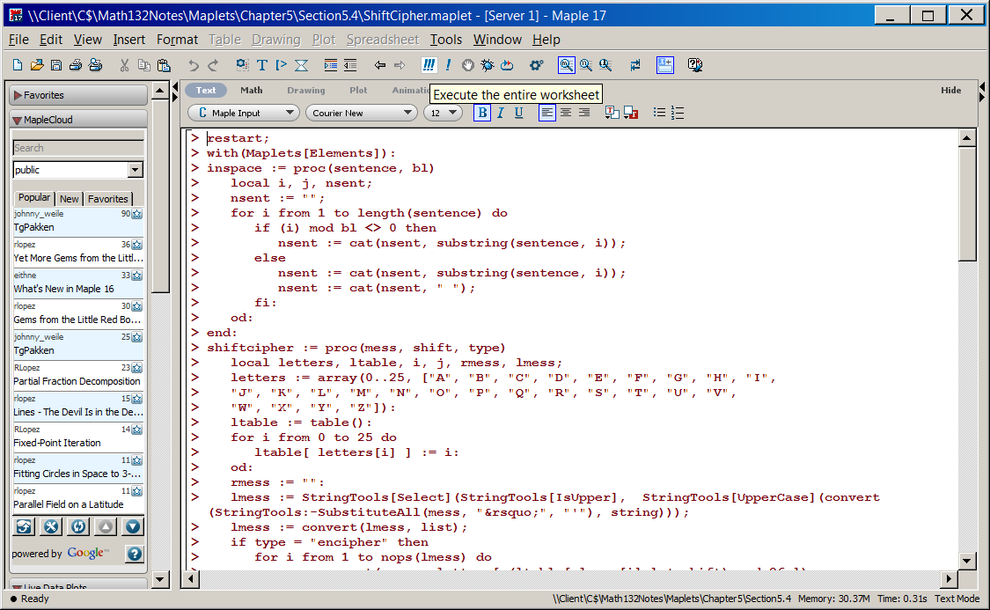

This will load in your Maple, and you are ready to get started.

