Getting Started Student Guide:

Enhanced WebAssign®

Engage with Enhanced WebAssign by following these easy steps!

Register

1. Visit <https://www.webassign.net/>
2. Then click ENTER CLASS KEY and go enter your Class Key, which is: **radford 2921 2096**
3. OR

**2a** Text EWA to 80565 and click on “I have a class key”.

**2b** Then enter your Class Key, which is: **radford 2921 2096**

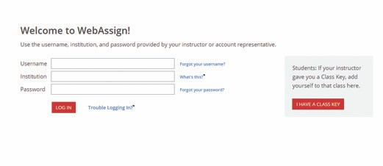

.

**2b 2c**

Purchase Options

**After logging in, you will see a notice that shows three payment options:**

**3a** If you do not have an access code card: Purchase access online (then go to step 4).

**3b** If you have an access code card: Enter your access code (then go to step 4).

**3c** Enter the course under a trial period (then go to step 4). After the trial period ends, you must enter an access code to continue working assignments and accessing your grades.

**3a**

**3b**

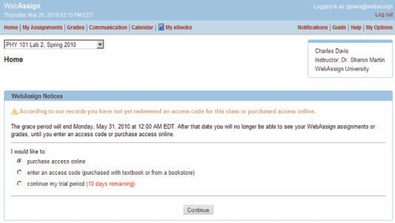

**3c**

WebAssign® is a registered trademark of Advanced Instruction Systems, Inc.

You’re All Set!

**4** You’ve successfully registered for Enhanced WebAssign!

The courses that have been set up for you by your instructor(s) appear on your Enhanced WebAssign personalized Home page. If you have more than one course, simply select the course you

want to work with from the pull-down menu.

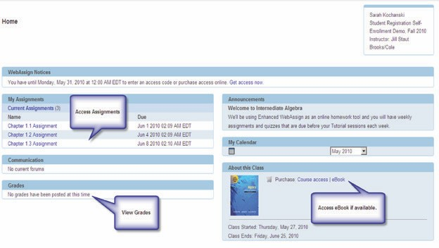

“The whole format of Enhanced WebAssign was outstanding.

If you didn’t understand something presented one way, there was always another way to learn it.”

Amanda Whitworth



Student, Columbus State University

Questions?

**Have questions about**

**your Enhanced WebAssign account?**

**ONLINE:**

Check the FAQs in the Student

Support area of Enhanced WebAssign: [**www.webassign.net/user_support/ student/**](http://www.webassign.net/user_support/)

**EMAIL:**

[**student_help@webassign.net**](mailto:student_help@webassign.net)

**PHONE SUPPORT:**

**Toll-free: (800) 955-8275**

**Local: (919) 829-8181**

Monday through Friday:

9:00am to 10:00pm (EST)

Sunday:

11:00am to 8:00pm (EST)

**LIVE CHAT:**

[**www.cengage.com/support**](http://www.cengage.com/support)

24/7 live chat!

Sign in using your CengageBrain credentials and create a case.

Once your case is submitted, you’ll receive access to 24/7 live chat!

Or you can speak with an agent by calling the phone number provided

upon your case submission.

**Text EWA to 80565 to**

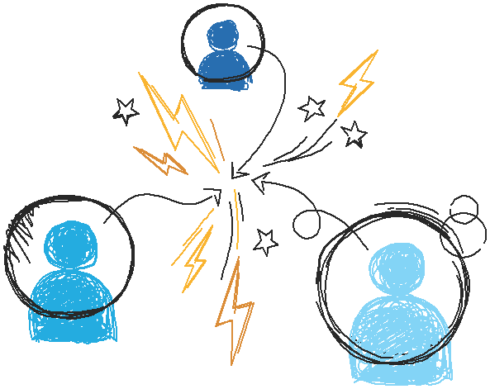

**register for your course.**

M16011747 | Updated: 12/15