Row Reducing an Augmented System using the TI-84

In this section, we demonstrate how to solve a system of equations using the result of row-reducing an augmented matrix using the TI-84. As a preliminary step to ensure the TI-84 attempts when possible to display answers in exact form with fractions, we put the calculator in FRAC mode. This can be done by pressing the MODE key

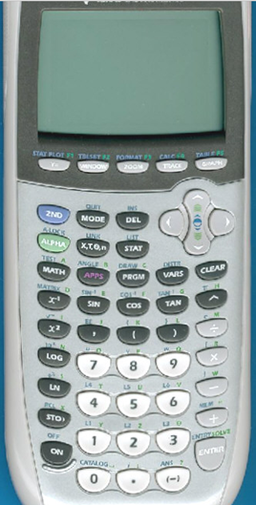

You will get the screen on the furthest left of the following figures. After using the arrow key on the upper right of calculator keypad to scroll down, you want to scroll to Answers and high FRAC.

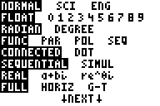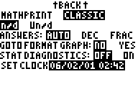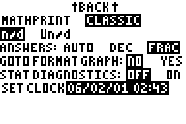

Then, just press 2nd Mode (this will access the blue second function QUIT) to get back to the home screen.

To demonstrate an example, suppose we want to solve the system of equations

$$\begin{matrix}x + y + 4z & & 2 \\ 2x + 5z & & 4 \\ 3x + 2y +4z & & −7\end{matrix}$$

Putting this system into augment matrix form gives the $3×4$ matrix

Our first step is to store this matrix into the calculator. To this, we first type 2nd $x^{−1}$ to access the MATRIX function.

You will get a screen similar to this:

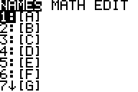
To enter this and store this matrix in the variable A, we use the arrow keys to scroll to EDIT, press the EDIT key. You should get screens that look like this.

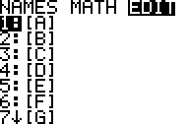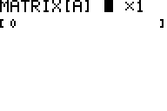

Since the matrix is $3×4$, we enter the size and then entries of the matrix, using the arrow keys when appropriate to scroll to the right. Your screen will look something like

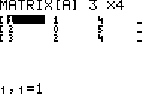

You can exit this mode by entering 2nd Mode (QUIT).

To solve this system, there are two built-in calculator functions in the MATRIX menu, ref (reduces the matrix to row-echelon form) and rref (reduces the matrix to reduced row-echelon form. To get the row-echelon form matrix using ref, we type 2nd $x^{−1}$ (MATRIX), scroll to MATH, and the scroll down to option A, which is ref, and press ENTER. The following screenshots summarize what you should be seeing.

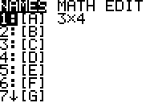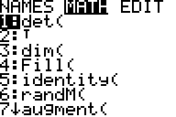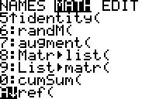

Once ENTER is pressed, you will return to the homescreen and see something like


Now, type 2nd $x^{−1}$ (MATRIX), and immediately hit ENTER under NAMES (matrix number 1 [A] should be highlighted). You will be returned to the homescreen. Enter the right parenthesis to finish the command and you will get the row-echelon form as output. As you progress, you should see something like.

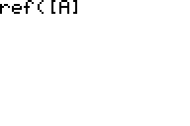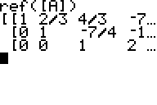

Reforming the equations (you will need to scroll to the right to see all of the entries of the augmented matrix)

$$\begin{matrix} \text{x }+ 2/3\text{y }+ 4/3z & & −7/3 \\ \text{ y} − 7/4z & & −{\text{13}}/2 \\ \text{ z } & & 2\end{matrix}$$

Using back substitution gives

$$\begin{aligned}z=2 \\ \\ y−7/4⋅(2)={−\text{13}}/2 \\ ⇒y−7/2={−\text{13}}/2 \\ ⇒y={−\text{13}}/2+7/2 \\ ⇒y={−6}/2 \\ ⇒y=−3 \\ \\ x+2/3⋅(−3)+4/3⋅2={−7}/3 \\ ⇒x−2+8/3={−7}/3 \\ ⇒x={−7}/3−8/3+2 \\ ⇒x={−\text{15}}/3+2 \\ ⇒x=−5+2 \\ ⇒x=−3\end{aligned}$$

Thus, the solution is x = -3, y = -3, z = 2

Suppose we want generate a table of values for the function $g(x)=0\text{.}4x^{2}−6x−0\text{.}1$ for the interval $x=−5,−4,−3,…,4,5$. To enter the function g, we must access the Y= screen. To get there, type ♦ F1. You will get a screen that looks like

y1 =
y2 =
y3 =
y4 =

To enter g(x), enter 0.4*x^2 – 6*x – 0.1 beside y1. After entering g, you should have something beside y1 looking like

√ y1 = $\text{.}4x^{2}−6x−\text{.}1$

Make sure the √ mark is placed to the left of y1 indicating the function is turned on and a table of values can be generated. Typing F4 will either turn on or off the √. After the function is entered, you can quit this menu by typing 2nd ESC.

We next want to set up the table parameters. To do this, we need the TblSet menu, which is accessed by typing ♦ F4. You will see a window that looks like

TABLE SETUP
tblstart:
$Δ$tbl:

Graph <-> Table: OFF →

Independent: AUTO →

Enter=SAVE

ESC=CANCEL

1.

-5.

The tblstart parameter represents the input x value where the table will begin. Since we are graphing $g(x)=0\text{.}4x^{2}−6x−0\text{.}1$ from $x=−5,−4,−3,…,4,5$, we set tblstart equal to –5.
$Δ$tbl represents how far the input x values in the table should be spaced. Here, x increases by 1 from one point to the next so we set $Δ$tbl = 1.The Graph <-> Table parameter is designed to generate a table of ordered pairs used to graph the function. Since we are not graphing g(x) in this example, this parameter should be left as OFF. The Independent parameter gives the user two options. If Auto is entered, the calculator will generate the table automatically. If Ask is entered, the user will have to input his or her own x values. We set this parameter as Auto to get the calculator to do the work for us. After these values are enter, press ENTER to save the new parameters.

To see the table, press ♦ F5. You should see a table similar to

x | y1
-5 | 39.9
-4 | 30.3
-3 | 21.5
-2 | 13.5
-1 | 6.3

To see the rest of the table, use the arrow key to scroll down. If you keep scrolling past x = 5, you will see that more table values will be generated.

It is easy to generate tables for all types of intervals. For example, if we wanted to generate a table for $g(x)=0\text{.}4x^{2}−6x−0\text{.}1$ for the interval from $x=0,0\text{.}5,1,1\text{.}5,…3\text{.}5,4$, we would enter this on the TblSet menu

TABLE SETUP
tblstart:
$Δ$tbl:

Graph <-> Table: OFF →

Independent: AUTO →

Enter=SAVE

ESC=CANCEL

0.

.5

to generate this table:

x | y1
0. | -.1
.5 | -3.
1. | -5.7
1.5 | -8.2
2 | -10.5

The TI 89/92 also can generate tables for multiple functions. For example, suppose we desire to generate a table for the functions $S_{1}(t)=\text{16}+2t$, $S_{2}(t)=\text{16}+t+0\text{.}5t^{2}$, and $S_{3}(t)=\text{16}+t−0\text{.}5t^{2}$ for the interval $t=0,1,2,…,6,7$. Accessing the Y= menu using ♦ F1, we enter these functions noting that we must enter these functions on the calculator in terms of the variable x.

√ y1 = 16 + 2*x
√ y2 = 16 + x +0.5*x^2
√ y3 = 16 + x – 0.5*x^2
y4 =

Setting up the Tblset menu as

TABLE SETUP
tblstart:
$Δ$tbl:

Graph <-> Table: OFF →

Independent: AUTO →

Enter=SAVE

ESC=CANCEL

0.

1.

,

we generate a table that looks like

x | y1 | y2 | y3
0. | 16 | 16 | 16
1. | 18 | 17.5 | 16.5
2. | 20 | 20 | 16
3. | 22 | 23.5 | 14.5
4. | 24 | 28 | 12

