Math 116 Practice Final Exam

- Find the missing side x of the following triangle.

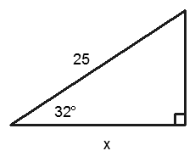
(A) 15.6
(B) 21.2
(C) 13.2
(D) 18.0

- Negate the following statement. Some elephants have tails.
  - All elephants have tails
  - No elephants have tails
  - Some elephants do not have tails
  - Some elephants hide their tails

- Let p = ”Clark lives in Smallville” and q = ”Lois lives in a Metropolis”. Which statement is symbolized by ∼ p ∧ q
  - Clark doesn’t live in Smallville and Lois lives in Metropolis.
  - Either Clark doesn’t live in Smallville, or Lois lives in Metropolis.
  - Neither Clark doesn’t live in Smallville, nor Lois lives in Metropolis.
  - Clark lives in Smallville and Lois lives in Metropolis.

- Which of the following statements is a tautology?
  - (p → q) ∧ q
(B) ((p → q) ∧ q) → p
(C) ((q → p)∧ ∼ p) →∼ q
(D) None of the above

- Which type of perspective makes use of a focal point to create depth in the artwork ?
  - Diminishing Sizes
  - One Point Perspective
  - Atmospheric Perspective
  - All of the above
- How many possible subsets does a set with 8 elements have?
  - 64
(B) 128
(C) 256
(D) 512

- Write the prime factorization of 240. (A) 22 · 3 · 52
(B) 2 · 34 · 5
(C) 23 · 3 · 5
(D) 24 · 3 · 5
- Which of the following numbers is a prime?
(A) 215
  - 53
(C) 442
(D) 119

- Convert the following base two number 11110102 to a base ten number. (A)154
(B) 122
(C) 128
(D) 109

- Convert the following base ten number 250 to a base two number. (A) 111010102
(B) 110010102
(C) 111110102
(D) 101001102

- Convert the following base ten number 523 to a base five number. (A) 40045
(B) 40435
(C) 44035
(D) 404305
- Which of the following sets is not well defined
  - {x : x is a city in the state of New York}
  - {x : x is a genius}
  - {x : x is an integer}
  - {x : x is a country in Asia}
- Which of the following statements are true.
  - a ∈ {a, b, c, d}
(B) {b} ∈ {a, b, c}
(C) {1, 2, 3, 5} ⊂ {1, 3, 5}
(D) All of the above
- Let A = {a, b, c, d, e}, B = {c, d, e, f, g}, and C = {a, b, c}. Which set would represent
A ∩ B ?
  - ϕ
  - {a, b, c, d, e, f, g}
  - {f}
  - {c, d, e}
- Using sets A, B, and C from problem 14 above and the universal set U = {a, b, c, d, e, f, g, h, i, j}
find (A ∩ C)’
  - {d, e, f, g, h, i, j}
  - ϕ
  - {a, b, c, d, e}
  - {a, c}
- Given that n(A) = 100, n(B) = 90, and n(A ∩ B) = 18, find n(A ∪ B) (A) n(A ∪ B) = 172
(B) n(A ∪ B) = 190
(C) n(A ∪ B) = 10 (D) n(A ∪ B) = 208
- Which of the following sets is a proper subset of {1, 2, 3, 4, 5} (A) {1, 2, 3, 4, 5}
(B) {1, 2, 6}
(C) {1, 2, 3}
(D) {1, 6}
- If a carpenter wants to make sure that a corner of a room is square and measures out 5 ft and 12 ft along the walls. How long should he make the diagonal?
  - 12 feet
  - 14 feet
  - 13 feet
  - 15 feet

- A television antenna is to be erected and held by guy wires. If the guy wires are 40 ft from the base of the antenna and the antenna is 50 ft high, what is the length of the guy wire?

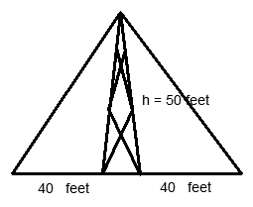
  - 64 feet
  - 72 feet
  - 78 feet
  - 83 feet
- Construct a truth table for the statement: (∼ p →∼ q) ∨ p
- Determine the validity of the following argument.
If you build the ball park in the field, then the ball players will come The ball players didn’t come
Therefore, You didn’t build the ball park in the field .
  - Valid
  - Invalid
  - Neither valid nor invalid

- Negate the following statement: Either Bill went to the dance, or Mary went to the movies.
  - Bill didn’t go to the dance and Mary didn’t go to the movies.
  - Either Bill went to the dance, or Mary didn’t go to the movies.
  - Bill didn’t go to the dance or Mary didn’t go to the movies.
  - None of the above
- Which is not a statement?
  - Richmond is the capital of Virginia
  - The car is green
  - When is our final exam ? (D) 3 + 6 = 9
- Given that the triangles are similar, find the missing values

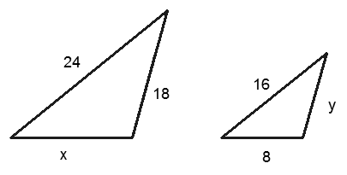
(A) x = 20, y = 12 (B) x = 12, y = 12 (C) x = 18, y = 12 (D) x = 12, y = 18
- A person who is 6 feet tall casts a 4 foot shadow at the same instant that a tree casts a shadow of 24 feet. How tall is the tree?
  - 12 feet
  - 20 feet
  - 36 feet
  - 48 feet
- Which one of the following pictures demonstrates one point perspective?

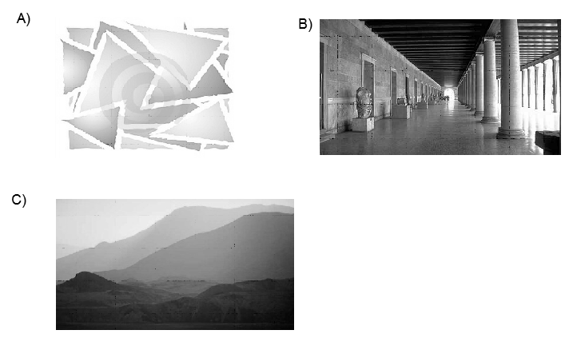

- Sketch the first three stages of the fractal with the given initiator and generator.

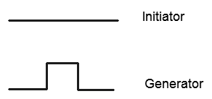

- Find the dimension of fractal with a scaling ratio r = 4, and a replacement ratio of N
= 6 . Round you answer to the nearest hundredth. (A) .766
(B) .862
(C) 1.16
(D) 1.29

- Find the volume of a cylinder shaped water tank that has a radius of 1.5 feet and a height of 4 feet.
(A) 20.2ft3
(B) 24.5ft3
(C) 28.3ft3 (D) 117.8ft3
- Find the area of a soup can label if the soup can is 10 cm in height and has a radius of 4 cm.
(A) 192.8 cm2
(B) 251.3 cm2
(C) 311.4 cm2
(D) 345.6 cm2
- Suppose a series of trees of the same size are a part of a one point perspective drawing. The letters a,b,c,d, and e and represent heights or distances given by the following figure. If a = 40 feet, c = 80 feet, and d = 100 feet, find b.

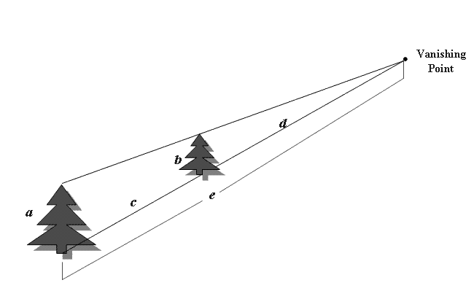
  - 28 feet
  - 22.2 feet
  - 14.5 feet
  - 11.2 feet

- Find the width and length to the nearest tenth of a Golden Box that has a height of 10 centimeters.
(A) L = 26.2 cm: W = 16.2 cm (B) L = 16.2 cm: W = 26.2 cm
(C) L = 3.8 cm: W = 6.2 cm
(D) L = 6.2 cm: W = 3.8 cm
- Is the following cross a Golden Cross
  - The cross is not a Golden Cross
  - The cross is a Golden Cross

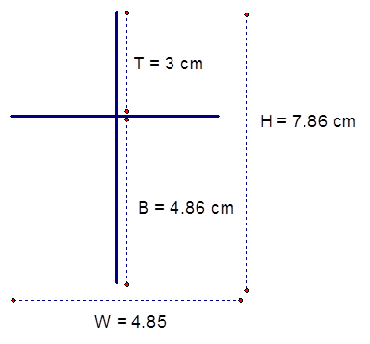
- Given AB = 12, BC = 2x + 4, CD = 10, and AD = 36, find the length of BC.

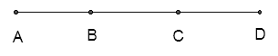
  - 10
  - 12
  - 14
  - 16
- Negate the following symbolic statement using De Morgan’s Laws: ∼ r∧ ∼ s
  - r ∨ s
  - r ∧ s
  - ∼ r∨ ∼ s
  - ∼ r∧ ∼ s
- Convert the base six number 35246 to a base four number (A) 31424
(B) 31034
(C) 310304
(D) 313204

Solutions:
- B
- B
- A
- C
- B
- C
- D
- B
- B
- C
- B
- B
- A
- D
- A
- A
- C
- C
- A
(∼ p →∼ q) ∨ p
T
T
F
T

20.

- A
- A
- C
- B
- C
- B
- NA
- D
- C
- B
- B
- A
- B
- C
- A
- C

