**Math 116: Written Homework Assignment Name:**

**This homework set is due Tuesday, December1st . Show work when possible. Answers magically appearing with no work receive no credit.**

1. Enter the letter of the image below that best matches the perspective description. This is the list of perspectives: (1 pt each)

 **i.** Atmospheric Perspective  **ii.** Not very much perspective is used  
 **iii.** Overlapping Shapes  **iv.** One-point Perspective

This is the permuted list of answers (click on the given image to make larger):

1.  **b.** 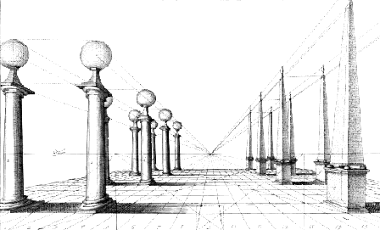

**c. 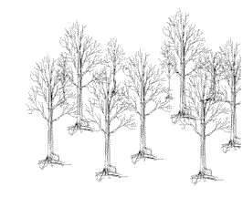 d.** 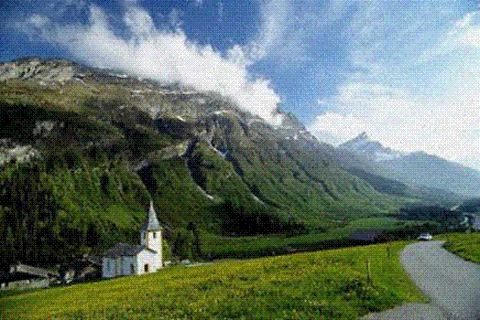

2. Enter the letter of the image below that best matches the perspective description. This is the list of perspectives: (1 pt each)

 **i.** Not very much perspective is used  **ii.** Atmospheric Perspective  
 **iii.** Overlapping Shapes  **iv.** Diminishing Sizes.  
 **v.** One-Point Perspective

This is the permuted list of answers (click on the given image to make larger):

1. 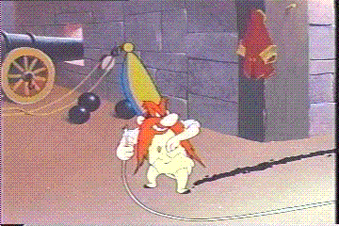 **b.** 

**c.**  **d.** 

**e.** 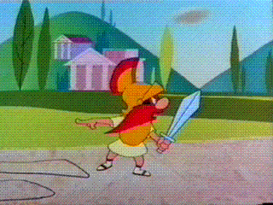

3. Use the following picture and the values of *a*, *b*, *c*, *d*, and *e* to find the missing  
values. Round your answer to 2 decimal places.

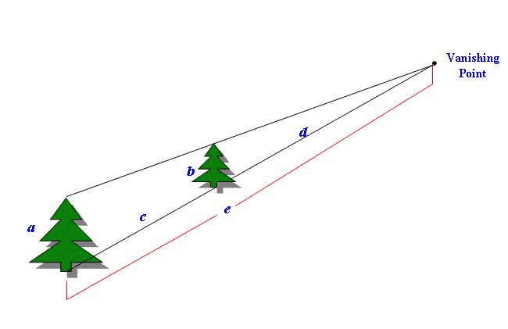

a. If *a* =10 in, *d* = 18 in, and *e* = 30 in, find *b* and *c.* (6 pts)

1. If *a* =5 in, *b* = 3 in, and *e* = 12 in, find *c* and *d.* (6 pts)

4. Suppose one dimension of a Golden Rectangle is 85 cm. Rounding your answer to one decimal place and using the approximation $φ≈1.62$ for the Golden Ratio, find the two other possible values for the other dimension of the Golden Rectangle. (6 pts)

5. Find the width *W*, bottom section *B*, and top section *T* of the Golden Cross, using the approximation $φ≈1.62$ for the Golden Ratio if the height of the cross is *H* = 132 cm. Round your answer to one decimal place. (6 pts)

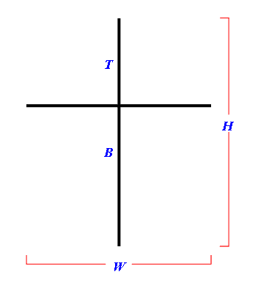

6. Using the picture below representing a Golden Box and the approximation $φ≈1.62$ for the Golden Ratio, find the missing dimensions for the given dimension. Round your answer to one decimal place.

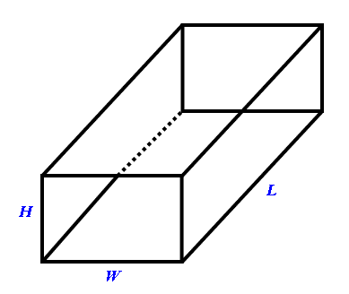

1. Find the width *W* and length *L* of the box if the height of the box is *H* = 325 cm. (6 pts)
2. Find the width *W* and height *H* of the box if the length of the box is *L* = 67 cm. (6 pts)