**Math 116: Written Homework Set 11**

**This assignment is due on Thursday, November 30th in class. Show all work where possible! Answers magically appearing will receive no credit.**

1. Determine the keyboard letter notes represented by the following integers using the following keyboard:

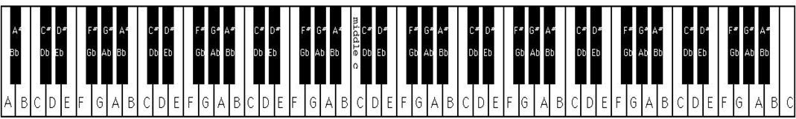

**Entire 88 Note Piano Keyboard with Notes Labeled**

a. $-25$

b.

c. 5

d. 45

2. The fourth B from the left on the piano keyboard is assigned to frequency 246.9 Hz. Find the frequencies of the following notes. Round to the nearest tenth.

a. The frequency of the B three octaves to the left of the fourth B

b. The frequency of the B two octaves to the right of the fourth B

3. The sixth F♯ from the left on the piano keyboard is assigned to frequency 1480 Hz. Find the frequencies of the following notes. Round to the nearest tenth.

a. The frequency of the F♯ four octaves to the left

b. The frequency of the F♯ one octave to the right

4. Suppose a note has a frequency of 196 Hz. Find the frequencies of the notes obtained by moving up the following intervals from this note. Round to the nearest tenth.

a. A third

b. A fourth

c. A fifth

d. A sixth

e. An octave

**Selected Answers**

1. a. B

c. F

2. a. 30.9 Hz

3. b. 2960 Hz

4 a. 245 Hz

c. 294 Hz

e. 392 Hz