**Math 116: Written Homework Set 2**  
  
**This assignment is due on Thursday, January 31st in class. Show all work where possible! Answers magically appearing will receive no credit.**1. Convert the following base two binary numbers to decimal (base 10) form.

2. Convert the given numeral from the given base to base 10 (decimal)  
 a.   
 b.

3. Convert the given base 10 decimal numeral to the indicated base.  
 a. 117 to base 2 (binary)

b. 267 to base 7  
 c. 7692 to base 16

4. Convert the following base five number to a base three number.

5. Use the method of trial divisions (square root test) to determine if the following numbers are prime.  
 a. 203  
 b. 701  
  
6. Write the prime factorization of the following numbers in canonical form.

a. 425

b. 7425

7. Determine the following angles.

a. The complement of ${54}^{o}$.

b. The supplement of .  
  
8. Given that $<ABC$ is a right angle in the diagram below, find the measure of $<ABD$

and $<CBD$.

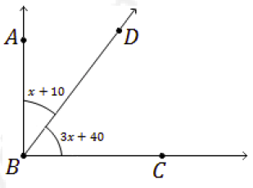

**Selected Answers**1. b. 1961

2. a. 73

3. a.   
 b.   
  
5. a. , not prime  
  
6. b.   
  
7. a.

8. a.