**Math 116: Written Homework Set 3**  
  
**This assignment is due on Tuesday, February 5th in class. Show all work where possible! Answers magically appearing will receive no credit.**

1. Find the circumference and area of the following circle.  
  
 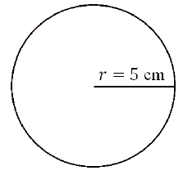

2. Your living room floor is roughly 18 feet by 16 feet, and you want to put down hardwood floors. Find the area of the floor and cost (not including labor) to put down hardwood flooring in your living room if the cost of the flooring is $5.00 per square foot.

3. Find both the volume and surface area of the following rectangular solid.

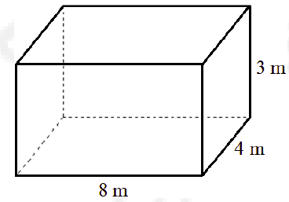

4. Suppose you have a cylindrical hot water heater with a height of 5 feet and a radius of 1 foot. How much water can it hold in cubic feet?

5. Solve the proportion for *x*

6. Find the value of *x* in the following diagram given that triangles $∆ABC$ and $∆DEF$ are similar.

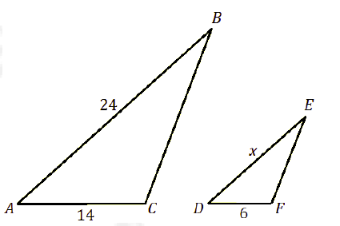

7. Given that triangles $∆DEF$ and $∆MNO$ are similar, of DF = 57 cm, EG = 36 cm, and MO = 19 cm, find the area of .

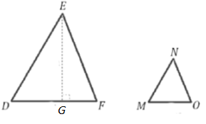

8. John is 6 feet tall. One afternoon, he cast a shadow 16 feet long. At the same time, a Maple

tree in John’s yard cast a 64-foot shadow. How tall is John’s maple tree?

**Selected Answers**  
1. Area =   
  
3. Volume =

5.

6.

8. 24 ft