Audrey Bevel

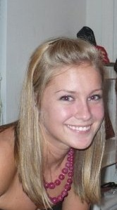
Hometown
Midlothian, VA
Pledge Class
Spring 2008
Big
Erica Kappert

