Caitlyn Reynolds
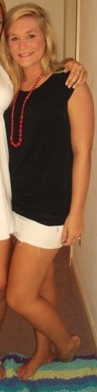

Hometown
Richmond, VA
Pledge Class
Spring 2008
Big
Erica Kappert

