Courtney Armisted
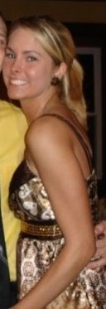

Hometown
Richmond, VA
Pledge Class
Spring 2008
Big
Shannon Ferrell

