Lo Honeycutt
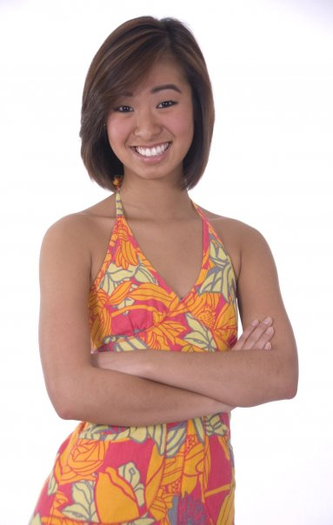

Pledge Class
Spring 2008
Big
Megan Moore

