Meredith Loving

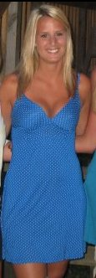
Pledge Class
Spring 2008
Big
Kristan Anderson

